|  |  |  |
| --- | --- | --- |
|  |  |  |
|  |  |  |
|  |  | ANNEX 6 – USER MANUAL //  GGIA TOOL  Quantitative Greenhouse Gas Impact Assessment Method for Spatial Planning Policy  Adjusted Annex // September 2022 |

a

This ANNEX 6 – USER MANUAL is conducted within the framework of the ESPON 2020 Cooperation Programme, partly financed by the European Regional Development Fund.

The ESPON EGTC is the Single Beneficiary of the ESPON 2020 Cooperation Programme. The Single Operation within the programme is implemented by the ESPON EGTC and co-financed by the European Regional Development Fund, the EU Member States, the United Kingdom and the Partner States, Iceland, Liechtenstein, Norway and Switzerland.

This delivery does not necessarily reflect the opinions of members of the ESPON 2020 Monitoring Committee.

Authors

Rebecca Cachia (Codema); Damiano Cerrone (TalTech); Donna Gartland (Codema); Kristi Grišakov (TalTech); Jukka Heinonen (University of Iceland); Kaie Kriiska (SEI Tallinn); Kimmo Lylykangas (TalTech); Ulrich Norbisrath (TalTech); John O’Shea (Codema); Anni Oviir (TalTech); Jenni Partanen (TalTech); Kaja Peterson (SEI Tallinn); Peter R. Walke (SEI Tallinn).

Advisory group

Travis O’Doherty and Nicci Nolan (lead stakeholders from Eastern and Midland Region of Ireland); Simon Bonsall (stakeholder from Scottish Government – Planning, Architecture and Regeneration Division); Catherine McEvoy and Simon Kelly (stakeholders from Department for Infrastructure, Northern Ireland); Anna-Riikka Karhunen and Elina Ronkanen (stakeholders from the Regional Council of Kymenlaakso); Marjan van Herwijnen (project expert) and Marta Roca (financial expert) (ESPON EGTC).

Acknowledgements

Jukka-Antero Aaltonen (City of Tampere); Sarah-Jane Burns (NTA); Barry Colleary (NTA); Pia Hastio (City of Tampere); Joonas Hendrik Kokamägi (TalTech); Ulla Lautaoja (City of Tampere); Michael MacAree (NTA); Claire Marion (City of Edinburgh); Erno Mäkinen (City of Tampere); Sander Peterson (TalTech); Merlin Rehema (SEI Tallinn); Ville Räty (Kymenlaakson liitto) and Heikki Savikko (Ramboll).

Information on ESPON and its projects can be found at www.espon.eu.

The website provides the possibility to download and examine the most recent documents produced by finalised and ongoing ESPON projects.

ISBN: 978-2-919816-19-4

© ESPON, 2022

Published in September 2022

Graphic design by BGRAPHIC, Denmark

Printing, reproduction or quotation is authorised provided the source is acknowledged and a copy is forwarded to the ESPON EGTC in Luxembourg.

Contact: [info@espon.eu](mailto:info@espon.eu)

|  |  |  |
| --- | --- | --- |
|  |  |  |
|  |  |  |
|  |  | ANNEX 6 – USER MANUAL //  GGIA TOOL  Quantitative Greenhouse Gas Impact Assessment Method for Spatial Planning Policy  Adjusted Annex // September 2022 |

|  |  |  |
| --- | --- | --- |
|  |  |  |

Table of contents

Abbreviations 7

1 The GGIA tool 9

1.1 Introduction 9

1.2 A tool for GHG quantification in spatial planning 9

1.3 Two perspectives: territorial and consumption-based 9

1.3.1 Territorial quantification 10

1.3.2 Consumption-based quantification 10

1.3.3 GGIA tool structure 10

1.4 Users 11

1.5 Utilization of previous GHG studies 11

1.5.1 Areas without previous GHG inventories 11

1.5.2 Areas with up-to-date local GHG inventory available 11

2 Walk-through – Planner User 12

2.1 Start page 12

2.2 Basic information 13

2.3 Transport 14

2.3.1 Transport Baseline 14

2.3.2 Transport Policy Quantification 16

2.3.2.1 New development 16

2.3.2.2 Policy quantification 17

2.3.3 Transport results 19

2.4 Land-use change 20

2.4.1 Land-use change Policy Quantification 20

2.4.2 Land-use change results 21

2.4.3 Land Use Analysis - example 22

2.5 Energy use in buildings 28

2.5.1 Buildings Baseline 28

2.5.2 Buildings policy quantification 29

2.5.2.1 New construction / densification 29

2.5.2.2 Retrofit and renovation policies 30

2.5.3 Buildings results 31

2.6 Consumption-based calculation 32

2.6.1 Creating a baseline 32

2.6.2 Household energy 32

2.6.3 Transportation 34

2.6.4 Consumption-based quantification results 35

2.7 Generate report 37

2.7.1 Results of territorial quantification 37

2.7.2 Results of consumption-based quantification 37

2.7.3 How to read the results? 37

2.7.4 How to continue with the process? 38

3 Quantification examples – Planner User 39

3.1 Reverse use 39

3.2 Comparison of policy impacts 39

3.3 New zero energy settlement 39

4 Local Datasets – Expert User 41

4.1 Local dataset for territorial quantification 41

4.1.1 Creating a local dataset for territorial quantification with the Excel tool 41

4.1.2 Creating a local dataset for territorial quantification in the GGIA tool 49

4.2 Local dataset for consumption-based quantification 50

4.3 Delivery of a new local dataset 52

4.4 Data validation 53

4.4.1 Validation principles for a local dataset serving territorial quantification 53

4.4.2 Validation principles for a local dataset serving consumption-based quantification 53

5 Access to code – Developer User 54

References 55

# Abbreviations

|  |  |
| --- | --- |
| BER  C40  CH4  CLC  CLMS  CO2  CO2e  COICOP  COPERT  CORINE  CRF  CSC  DOM  EEA  EEA39  EPC  ESDAC  ETRS89  FAO  FIPS  GHG  HBS  IPCC  LPIS  LULUCF  MMU  N2O  NFI  NIR  NPF  PRIMES  QGasSP  RSG  UNFCCC  WRB | Building Energy Rating  a network of the world’s megacities committed to addressing climate change  methane  Corine Land Cover  Copernicus Land Monitoring Service  carbon dioxide  carbon dioxide equivalent  Classification of Individual Consumption by Purpose  European tool for the calculation of emissions from the road transport  Coordinated Information on the Environment  Common Reporting Format  Carbon-Stock-Change  Dead organic matter  European Environment Agency  33 EEA member countries + 6 co-operating countries  Energy Performance Certificate  European Soil Data Centre  European Terrestrial Reference System  Food and Agriculture Organization of the United Nations  Forest Inventory and Planning System  Greenhouse Gas  Household Budget Survey  Intergovernmental Panel on Climate Change  Land Parcels Information System  Land use, land-use change and forestry  Minimum Mapping Unit  Nitrous oxide  National Forest Inventory  National Inventory Reports  National Planning Framework  Price-Induced Market Equilibrium System, a large scale applied energy system model  Acronym, Quantitative Greenhous Gas Impact Assessment Method for Spatial Planning Policy  Reference Soil Groups  United Nations Framework Convention on Climate Change  World Reference Base for Soil Resources |

List of maps, figures, charts and tables

List of figures

Figure 1. The structure of the GGIA tool. 10

Figure 2. Start page. 12

Figure 3. Basic information. 13

Figure 4. Transport module. 14

Figure 5. Land-use change module. 20

Figure 6. CORINE land cover classes (here Kymenlaakso). 25

Figure 7. Soil types from European Soil Database (here Kymenlaakso). 25

Figure 8. Example of GIS data processing (step 1). 27

Figure 9. Example of GIS data processing (step 2). 27

Figure 10. Buildings module. 28

Figure 11. Specification of area type and population for the consumption-based quantification. 32

Figure 12. Transport-related inputs for consumption-based quantification. 34

Figure 13. The first results graph, consumption-based quantification. 35

Figure 14. The second results graph, consumption-based quantification. 36

Figure 15. The third results graph, consumption-based quantification. 36

Figure 16. Example of results graph with construction emissions in 2026. 37

Figure 17. Creating a local dataset in the Excel tool. 42

Figure 18. A source for CSC factors, example (NIR Finland, Table 4.B, Inventory year 2019). 48

Figure 19. Local dataset creation in the GGIA tool. 50

Figure 20. HBS data applying the COICOP classification by UN. 51

Figure 21. Exiobase conversion worksheet. 51

Figure 22. Creation of household heating data for local dataset. 52

List of tables

Table 1. IPCC Land-use categories. 22

Table 2. IPCC LULUCF sector carbon pools. 23

# The GGIA tool

## Introduction

This manual provides guidance and explanations for using the ESPON GGIA tool created in the QGasSP project.

The objective of the QGasSP project (2020–21) was to produce a methodology that will allow competent planning authorities at national, regional and local administrative levels to quantify the influence of spatial planning policies on greenhouse gas (GHG) emissions in a consistent manner. The expected primary outcome of the QGasSP project was the development and delivery of a robust, simple and proportionate method for quantifying and forecasting the relative GHG impacts of alternative spatial planning policies, with pan-European applicability. The purpose of this method is to help inform strategic spatial policy alternatives at different administrative scales, and which can ultimately assist national, regional and local policy decision-makers across EU Member States and ESPON Partner States in meeting their GHG emission reduction targets.

## A tool for GHG quantification in spatial planning

The ESPON GGIA tool is a free browser-based, open source tool designed to estimate the greenhouse gas emissions in all scales of spatial planning in 32 European countries.

The GGIA tool provides an opportunity to estimate the greenhouse gas emissions of a territory, municipality or city of any size, applying either a territorial approach or a consumption-based approach.

Based on the European datasets and the user inputs, the tool first estimates the baseline emissions and generates a baseline scenario – an estimate of the future trajectory for the greenhouse gas emissions within the area of assessment. Basic calculation applies a publicly available future scenario for each European country (Capros et al, 2016) based on the PRIMES modelling, resulting to a baseline scenario that reflects the expected future developments without any impact of local GHG mitigation policies.[1]

Next the climate impacts of spatial plans or planning policies can be quantified in the GGIA tool. The GGIA tool asks planner user to describe the expected impacts of spatial plans and policies in units that planner is familiar with. Each description consists of two main inputs: quantification of the expected impact and the policy period (timing), for example: economic incentives to retrofit 400 buildings from energy class E to C during 2025–27, or: increasing the modal share of bus transportation from 10% to 15% by developing the provision of public transportation in 2030–2035. Based on these inputs, the GGIA tool can quantify the climate impact and display the reduction in GHG emissions against the baseline scenario.

With the GGIA tool, a planner is able to check whether a policy in concern has a significant climate impact.

The tool is designed so that a planner can start using it without any expert knowledge and the baseline emissions can be estimated with just a few clicks. When more accuracy is needed, a team of expert users can create a local dataset, with which the most accurate data available can be applied in quantification. If the territory or the city in concern already has done a GHG inventory, the emission factors and other relevant assumptions of the previous studies can be inserted in the local dataset.

Europe wants to be a climate neutral continent by 2050. Therefore the time period for the assessment with the tool starts from the selected baseline year and spans until year 2050.

## Two perspectives: territorial and consumption-based

The ESPON GGIA tool provides two alternative approaches in the quantification of greenhouse gas emissions for territories, cities and municipalities.

### Territorial quantification

Today most cities and regions apply a territorial approach that assesses the direct and indirect greenhouse gas emissions allocated to the geographic boundaries of the area in assessment. This approach is also applied in national greenhouse gas inventories. However, it is important to notice that not all the greenhouse gas emissions within the geographic boundaries are caused by the residents. On the other hand, the consumption of the residents causes a significant amount of emissions outside the area boundary.

### Consumption-based quantification

Consumption-based approach aims to assess the global greenhouse gas emissions for the residents of the area in assessment. This can be assessed for example with the statistical data on the economic consumption of households (household budget survey, HBS). Consumption-based results could be characterized as global carbon footprint of the citizens. It provides a holistic picture on total greenhouse gas emissions.

The GGIA approach follows the recommendation of the C40 cities network for climate action that promotes applying both approaches. The two approaches provide two different perspectives to the greenhouse gas emissions, complementing each other.

### GGIA tool structure

BASIC INFORMATION

CONSUMPTION-BASED

TERRITORIAL

RESULTS

Figure 1. The structure of the GGIA tool.

The structure of the GGIA tool is presented in Figure 1. Territorial quantification has a modular structure. More quantification modules, such as Waste or Embodied emissions, can be added later to extend the territorial quantification.

The main objectives of the tool are:

* To enable an easy start with GHG quantification for a planner user applying country-specific default data in the tool. A baseline for GHG emissions can be created with a very small number of inputs.
* To formulate the inputs so that the GHG quantification remains transparent and guides the planner to pay attention to the potential impacts on the main components of GHG quantification. For territorial quantification this is: **activity data** (for example delivered energy for buildings, annual need for transportation etc.) and **emission factor** (affected by modal share, share of renewable energy, propulsion of road vehicles etc.). For consumption-based quantification the key component of the quantification is economic consumption, resulting from life style that is not reflected in territorial approach.

## Users

This manual provides instructions for different kinds of users:

* A planner user for example a planner, who can quantify the GHG emissions of alternative spatial plans or policies without in-depth knowledge on GHG quantification methods. See chapter 2 and 3.
* An expert user, capable of creating and updating a local dataset that enables continuous and easy use with accurate local data. See chapter 4.
* A developer user, with the interest of modifying or extending the tool to improve and update its properties. See chapter 5.

## Utilization of previous GHG studies

One of the most important features of the GGIA tool is the local dataset function. From the GHG quantification perspective there are two kinds of use cases for the GGIA tool: areas that do not have a baseline emissions inventory, and areas that have an inventory available. The GGIA tool is designed to serve the both cases.

### Areas without previous GHG inventories

A planner user can create a baseline scenario in the GGIA tool without any previous GHG inventory available. In this case, GGIA applies top-down national data from European databases to create a baseline scenario. The data and the methodology applied are coherent for areas of any size and any location. However, it is important to notice that in this case the future trajectory includes neither any impact of climate action implemented after 2016 nor any impact of sub-national climate policies. The use of top-down data causes inaccuracy in the baseline analysis, but the relative GHG reduction gained by the implementation of a plan or a policy is rather accurately quantified also in this case.

### Areas with up-to-date local GHG inventory available

The local GHG inventories can make use of the most accurate data available, thus they are more accurate than any estimates based on national average values. Any municipality, city or territory that has already published a GHG baseline is probably not willing to accept less accurate baseline information in the assessment of its plans and policies. Unfortunately, there is no instance that would have collected numerous local GHG inventories from various parts of Europe in one database. Therefore, the GGIA tool provides an opportunity to upload a local dataset into the tool, and the owner of the tool can publish it in the tool. In other words, the data previously collected for a local GHG inventory can be inserted into the GGIA tool as a local dataset that overrides the national data in the quantification. The local dataset contains also all future projections, in which the expected impact of local climate policies can be taken included in the baseline scenario. However, the methodologies applied for collecting the local inventory data cannot be verified, which causes some uncertainty in comparisons of absolute GHG emissions.

Process of creating a local dataset is explained in detail in chapter 4.

# Walk-through – Planner User

This section reviews all the tool functionalities and the user inputs in all quantification modules.

In his manual, “Assessment area” refers to the area for which the GHG emissions are quantified: for example a municipality, town, city, territory or country. It may of any size and located anywhere in the 32 European countries included in this tool.

**Setting up a new project**

A new project is established by filling in the basic information (see below) and saving the project before closing the tool. The quantification can include only one module or several modules. Territorial and Consumption-based quantifications are alternative modes of GHG assessment, and the results cannot be summed up.

**Saving an assessment in progress**

The GGIA tool saves the inputs automatically on the local computer. When opened, the GGIA tool automatically returns the input values inserted during the previous session (until the most recent push of “Next” button).

## Start page

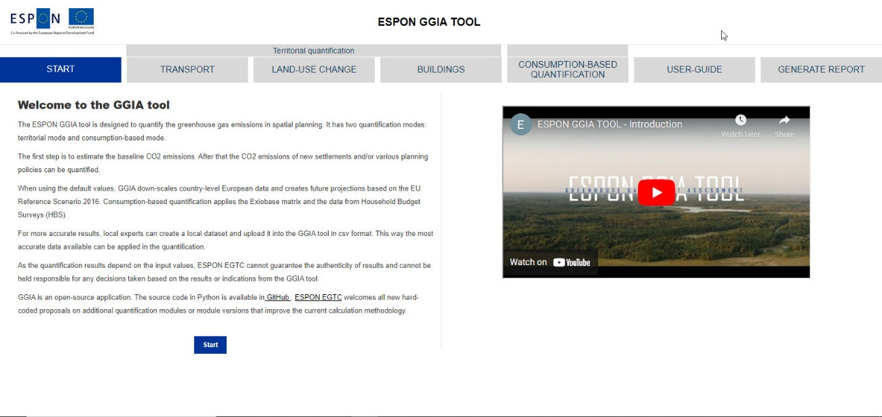

Figure 2. Start page.

Start page provides the basic information of the tool and a quick access to the general tool introduction video. The user manual can be viewed by clicking the “User guide” button in the navigation ribbon.

Click **Start** to begin the quantification.

## Basic information

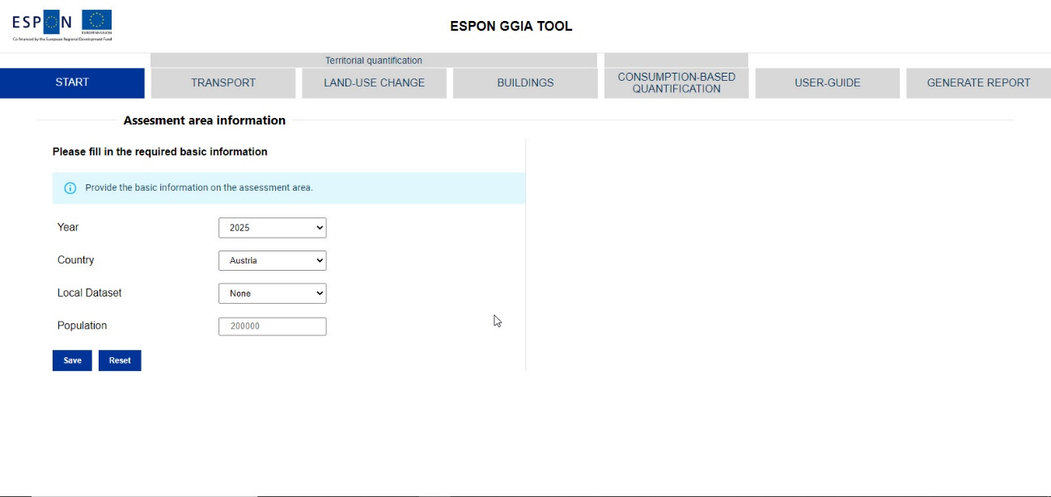

Figure 3. Basic information.

Provide here the basic information on the assessment area. Assessment area is the territory, city, municipality or any other area for which the GHG emissions are quantified. Territorial assessment quantifies the GHG emissions within the geographic boundaries of this area. Consumption-based assessment quantifies the global GHG emissions for the consumption of the residents in the specified area.

This basic information serves all quantification modules of the GGIA tool.

YearSelect the first year of the assessment period.

All assessments span from the selected year until 2050 when Europe aims to be a carbon neutral continent.

CountrySelect the country in which the assessment area is located. The tool contains datasets for 32 European countries.

Local datasetIf a Local dataset is available for your territory or city, it is likely to provide more accurate data for for the territorial quantification modules. Choosing this option means that the local data overrides the national level data provided by the tool in every calculation module. Please notice that the local datasets are created by the users of the tool. Instructions on how to create a local dataset can be found in chapter 4.

You can continue without choosing a local dataset. In this case the calculations are based on the country-level data from open European databases, such as Eurostat, EU Buildings Database and the National Greenhouse Gas Inventory (NIR) reports. An overview of all default data sources used can be found in the chapter 3 of Annex 1.

Population Insert the estimated total population of the assessment area in the end of the year that you have selected above.

Create a local dataset This button is an access to Local dataset writer for expert users, see chapter 4.

Press **Save** when all the fields are filled and the selections are done.

**Reset button** clears the input fields.

After this you can proceed to any calculation module of the tool by selecting it in the navigation ribbon.

## Transport

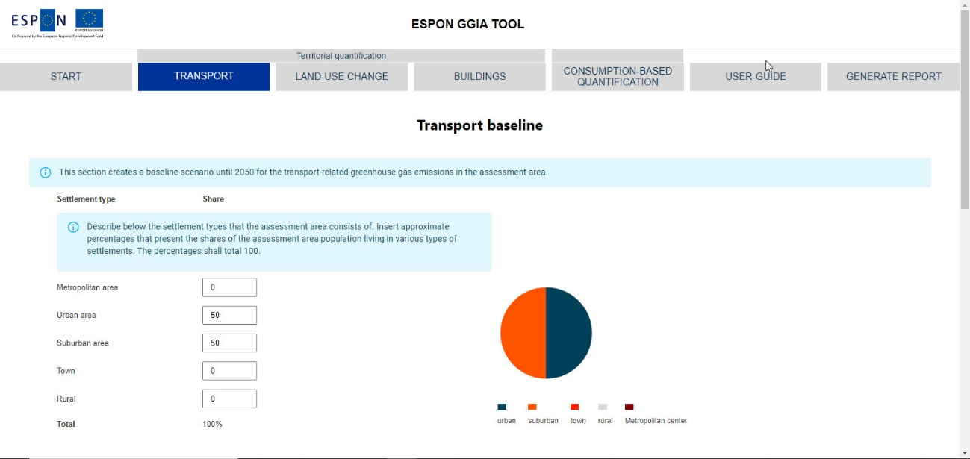

Figure 4. Transport module.

### Transport Baseline

This section creates a baseline scenario until 2050 for the transport-related greenhouse gas emissions in the assessment area. The modes of transportation included are:

* Bus
* Passenger car
* Tram
* Metro
* Passenger train
* Freight transport on rail
* Freight transport on road
* Freight transport on inland waterways.

**Settlement type**

These inputs are applied to down-scale the national average transport activity data to the assessment area. A higher car dependency is assumed for rural areas. In addition, these percentages define the driving profiles (shares of road driving and street driving) that are used to calculate the average emission factors for road transport (bus, passenger car, freight transport on road).

Describe here the settlement types that the assessment area consists of. The approximate percentages express the shares of the assessment area total population living in various types of settlements. The percentages shall total 100.

Metropolitan area Urban settlement characterized by superb provision of public transportation including metro and/or tram, large pedestrian zones and high density of population.

Urban area Urban settlement characterized by excellent provision of public transport and high density of population.

Suburban area Settlement dominated by private car transport and residential buildings; bus and train transportation available.

Town A local centre that is smaller than a city, providing commercial services to a larger area as well as public transportation (bus, train).

Rural Sparsely populated area with limited provision of public transportation (some bus connections only).

**Non-residential and freight**

Describe the intensity of non-residential passenger road transport and freight transport within the assessment area by selecting the best match from the menu options.

Non-residential road transport Select the closest option

Freight transport by road Select the closest option

Freight transport by rail Select the closest option

Freight by inland waterways Select the closest option.

**Metro systems included**

The tool displays a list of all the metro systems in the country that was selected on the Basic information page. Please specify the metro systems included in this assessment by inserting a percentage.

For all inputs insert a percentage (an integer in the range of 0–100)

100 = the emissions of this metro system are entirely included in this study.

0 = the metro system is excluded from this study.

If just one part of the local metro network is located within the assessment area, you need to estimate the share of the metro-kilometres included in this assessment. You can estimate the percentage by comparing the metro track length within the assessment area with the total track length of the local metro network.

**Tram systems included**

Specify the tram systems included in this assessment by inserting a percentage.

For all inputs Insert a percentage (an integer in the range of 0–100)

100 = the emissions of this tram system are entirely included in this study.

0 = the tram system is excluded from this study.

If just one part of the local tram network is located within the assessment area, you need to estimate the share of the tram-kilometres included in this assessment. You can estimate the percentage by comparing the tram track length within the assessment area with the total track length of the local tram network.

Click **Next** to see the baseline results.

**Baseline results**

After these inputs the tool provides a baseline scenario for the transport GHG emissions within the assessment area. The baseline scenario presents the expected future development for the transport sector. The sectoral future projection is based on the country-specific prognoses on

* Population change
* Decarbonisation of national grid electricity
* Scenarios on transport activity
* Expected increase of electric vehicles.

The default values for future projections are based on the EU Reference Scenario 2016 publication and the PRIMES modelling (Capros et al, 2016). The future projection does not include the impacts of local climate action plans. The current national scenario for grid electricity decarbonisation may differ from the default values. For example the expectations considering the market penetration of electric vehicles have changed radically during recent years. These assumptions can be revised in a local dataset.

Click **Next** to proceed.

### Transport Policy Quantification

**The policies that can be quantified**

The transport module can quantify the change in the annual GHG emissions caused by any policy that has an impact on

Activity data

* Change in the need for passenger transport or freight transport within the area of assessment
* Modal split (change in the modal shares of passenger transport) excluding the active modes of transport (walking, cycling etc.).

Emission factor

* Fuel types (engine types) in the road transport vehicle fleet
* Share of renewable energies in the transport electricity.

#### New development

This section estimates new residents’ impact on the transport-related greenhouse gas emissions.

The transport activity of the new residents is estimated in the same way than for the existing residents. The settlement type has an impact on the modal shares and driving profiles.

**New residents**

Insert the total number of new residents moving in as a consequence of the plan/policy that is assessed.

Number of new residents If the plan/policy will not increase the number of residents within the area, insert zero.

The population change that is not caused by the plan/policy should be excluded here. The tool applies a national scenario on the population change according to the EU Reference Scenario 2016 (Capros et al, 2016) in the baseline calculation.

Residents moving in Start year is the first year the when new residents are moving in. End year is the last year when the new residents are moving in.

**Settlement type**

Describe below the new settlements. Allocate approximate percentages of new population to various types of new settlements to indicate where the new residents will reside. The percentages shall total 100. These inputs will have an impact on both the transport activity and the emission factor of the new residents.

Metropolitan area Urban settlement characterized by superb provision of public transportation including metro and/or tram, large pedestrian zones and high density of population.

Urban area Urban settlement characterized by excellent provision of public tranportation and high density of population.

Suburban area Settlement dominated by private car transport and residential buildings; bus and train transportation available.

Town A local centre that is smaller than a city, providing commercial services to a larger area as well as public transportation (bus, train).

Rural Sparsely populated area with a limited provision of public transportation (some bus connections only).

Click **Next** to continue to see the GHG emissions caused by new development.

**New development results**

After these inputs the tool provides an overview on the climate impact of new development.

The estimated increase in transport activity is based on the number of new residents. This is adjusted by the modal share that depends on the user inputs on settlement type. If the new residents will inhabit rural areas only, passenger car transport is emphasized. Respectively, new residents in metropolitan areas are expected to use more public transportation.

Please notice that the buildings for new development have to be specified in the Buildings module.

Click **Next** to continue to policy quantification.

#### Policy quantification

This section estimates the impact of a plan or a policy on the transport-related greenhouse gas emissions.

**Passenger mobility**

Does the plan/policy reduce the need for motorized passenger transport within the assessment area? Estimate the change and the population affected below.

Decrease in mobility Reduction is inserted as a positive percentage. Please notice that this percentage is a reduction in all passenger transport in the area (including the passenger transport of residents and non-residents).

The mobility of new residents is already included in “New development”, according to the number of new residents and the specification of settlement types.

If the policy in concern increases the need for mobility within the assessment area, the climate impact can be quantified here by inserting a negative value. This kind of policy could be for example cutting the provision of services.

Population affected Estimate the percentage of the population that is affected by the policy.

Policy period Start year is the first year during which the policy changes the need for motorized passenger transport within the area. The change is assumed permanent after the last year of implementation.

**Freight transport**

Does the planning policy reduce the freight transport within the assessment area? Estimate the total change in the assessment area below.

Change in freight transport Reduction is inserted as a positive percentage.

Policy period Start year is the first year during which the policy changes the volume of freight transport within the area. The change is assumed permanent after the last year of implementation.

**Modal split, passenger transport**

Does the planning policy change the modal split of passenger transport within the area? Select the policy implementation period and insert the target percentages to be achieved by the end of the last year of the policy period.

Without policy This column shows the modal shares according to the baseline scenario.

With policy (Policy target) Insert the target percentages for public transportation. The remaining share is allocated to passenger car transport.

Policy period Start year is the first year during which the policy changes the modal share. The change is assumed permanent after the last year of implementation period.

Population affected Insert a percentage of population expected to change the modal share due to the planning policy. This share applies to the passenger transport of both residents and non-residents within the assessment area.

**Modal split, freight transport**

Does the planning policy change the modal split of freight transport within the area? Select the policy implementation period and insert the target percentages to be achieved in the end of the last year of policy implementation.

Without policy This column shows the modal shares according to the baseline scenario.

With policy (Policy target) Insert the target percentages for the freight transport on rails and on waterways. The remaining share is allocated to road freight.

Policy period Start year is the first year during which the policy changes the modal share. The change is assumed permanent after the last year of implementation period.

**Shares of fuel types in bus transport**

Does the planning policy increase the use of low-carbon fuels in the bus fleet that operates in the assessment area? Select the policy implementation period and insert the target percentages to be achieved by the end of the last year of policy implementation.

Without policy This column shows the fuel shares in the bus fleet as in the baseline scenario.

With policy (Policy target) Insert the target percentages for the fuel types used in the bus fleet by the end of the policy implementation period. The remaining share is allocated to diesel engines.

% of the area affected Insert a percentage of bus transport in the area affected by the planning policy.

Policy period Start year is the first year during which the policy starts to change the fuel shares. The change is assumed permanent after the last year of implementation period.

**Shares of fuel types in car transport**

Does the planning policy increase the use of low-carbon fuels in the passenger cars in the assessment area? Select the policy implementation period and insert the target percentages to be achieved by the end of the last year of policy implementation.

Without policy This column shows the fuel shares in the passenger car fleet as in the baseline scenario.

With policy (Policy target) Insert the target percentages for the fuel types of the passenger car fleet by the end of the policy implementation period. The remaining share is allocated to petrol and diesel engines.

% of the area affected Insert a percentage of passenger car transport in the area affected by the planning policy.

Policy period Start year is the first year during which the policy starts to change the fuel shares. The change is assumed permanent after the last year of implementation period.

**Electricity for transport**

Does the planning policy increase the share of renewable energies in the electricity that is used in transport? Insert a percentage that shows the additional share of renewable electricity in comparison to the average grid electricity.

Without policy This column shows the emission factor of the national grid electricity as in the baseline scenario.

Reduction Insert the percentage of renewable energies that is produced locally for the transport electricity. Positive percentage improves the electricity mix and reduces the average emission factor of the electricity provided for transportation. Please notice that generating renewable electricity for the national grid cannot be inserted here.

% of the area affected Insert a percentage of transport in the area affected by the policy.

Policy period Start year is the first year during which the share of renewables in transport electricity starts to increase. The change is assumed permanent after the last year of implementation period.

Click **Next** to see the policy quantification results.

### Transport results

The graph shows the impact of the plans/policies on the GHG emissions. The dashed line presents the baseline scenario. If the policy quantification shows less emissions than the baseline scenario, the plan/policy reduces the GHG emissions.

Please notice that new residents always increase the absolute emissions. Per capita emissions can show improvements although the total GHG emissions would increase.

## Land-use change

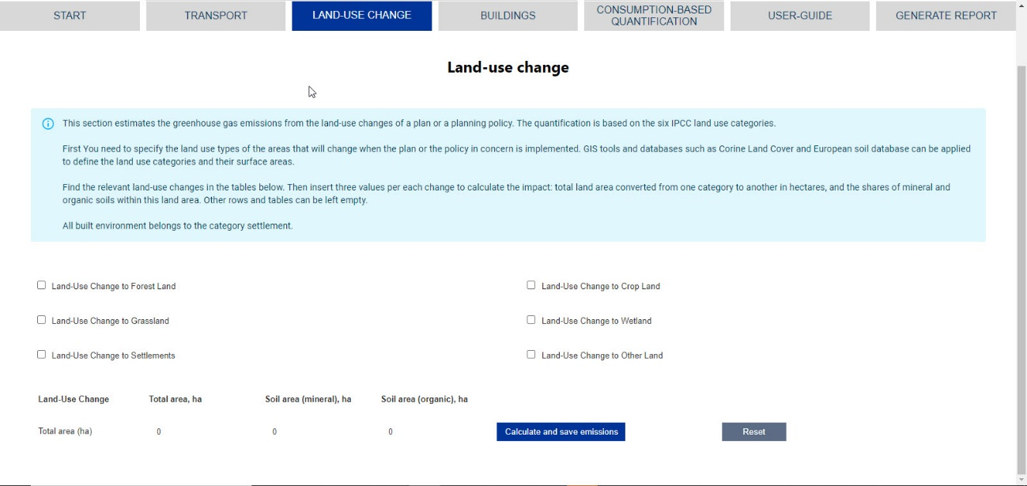

Figure 5. Land-use change module.

**The policies that can be quantified**

All spatial plans and policies that cause changes in land use within the area of assessment: for example building a new settlement, new railroad connection etc. The impact assessment is based on the six IPCC land use categories (see Table 1) and the country-specific Carbon-Stock-Change (CSC) factors collected from the attachments of the national inventory reports (NIR) in 2021.

### Land-use change Policy Quantification

The GGIA tool Land-use change module calculates the climate impacts that are caused when land is allocated to another purpose in spatial planning. Land use baseline analysis cannot be created with the GGIA tool.

**Planner User inputs**

Planner User inserts the land areas (in hectares) that are converted from one category to another as a consequence of a plan or a planning policy. In practise, planner first needs to analyse the land area that is subject to change, allocating it to one of the IPCC land use categories.

European, national or local databases can provide the necessary information. As described in Annex 1, CORINE Land cover database and European Soil database are examples of two data sources that can be used everywhere in Europe.

The input tables open by checking the title that indicates the land use after the policy is applied. Find the relevant land-use changes in the tables and insert three values per each change to calculate the impact:

* total land area converted from one category to another in hectares
* land area for mineral soil; and
* land area for organic soil within assessment area.

The fields for the changes that are not relevant can be left empty.

In addition to hectares, planner user needs to select the year when the specified land-use change is expected to take place.

All built environment belongs to the category «settlement».

Land use change Select the correct land use change. A new input table opens.

The GHG emissions for each land use change are calculated as a sum of six components utilizing the three user inputs: total area and the soil areas for mineral and organic soils.

More specific definitions of the national land-use categories can be found in Table 1 and National Inventory Reports (NIR) created for the national greenhouse gas inventories.

Total area, ha Insert the total area in hectares

Soil area (mineral), ha Insert the mineral soil area in hectares

Soil area (organic), ha Insert the organic soil area in hectares

The organic and mineral soils areas are subcategories for each land-use change**.** Calculation gives results also when the areas for mineral and organic soils are not inserted at all, but in this case some land-use change impacts may be excluded from the result.

Organic soils are identified on the basis of several criteria found in the IPCC guidelines, however, are mainly represented by Histosols (World Reference Base for Soil Resources). All other types of soils are classified as mineral. Thus **mineral and organic soil area sum up to total change area**.

**In land-use change, major impacts are usually caused by deforestation, i.e. all changes from forestland to some other land-use category.**

Please notice that some land-use change inputs may have no impact on the result. This may be because

* The specified land-use change impact is zero or very close to zero; or
* Dataset applied does not have a CSC factor for this specific land-use change.

The national default CSC factors (except for deforestation) are collected from national inventory reports (NIR, inventory year 2019) where the CRF tables do not necessarily provide values for all land-use change types.

Year of implementation Select the year when the land-use change is expected to happen.

When all the inputs are done, please click **Calculate and save emissions**. **Reset** returns zero hectares and year 2022 in all tables. Please click **Next** to see the results.

### Land-use change results

Net CO2 removals are negative (-) and net CO2 emissions are positive (+) results.

Please notice that a single land-use change has also long-term impacts that are estimated in the GGIA tool applying the IPCC methodology. Impacts are country-specific, but typically highest CO2 emissions are caused when forestland is converted to some other land-use category.

Please notice that there are some changes between land-use categories that do not change the result graph. This may be due to minimal impact on total GHG emissions, or due to the lack of respective carbon stock change factor in the National Inventory report published by the country in concern.

### Land Use Analysis - example

This chapter provides a detailed description of one method that can be used for the land use analysis that is needed for land-use change quantification. In order to apply the IPCC methodology, land must be divided under the default IPCC land-use categories.

The main GHG occurring in the LULUCF sector is CO2, while non-CO2 emissions (like CH4, N2O) are predominantly non-key categories, therefore only CO2 emissions are estimated in the GGIA tool.

IPCC provides the frame of six broad land-use categories (Table 1) and five carbon pools (Table 2) that form the basis of estimating emissions and removals from land use and land-use conversions. The categories are broad enough to classify all land areas in most countries and to accommodate differences in national land-use classification systems. The definitions of land-use categories may incorporate land cover type, land use based, or a combination of the two. Within each land-use category, emissions/removals resulting from carbon stock changes are estimated separately in the five carbon pools or may be based on the three aggregate carbon pools (i.e. biomass, dead organic matter (DOM) and soils) according to the IPCC methodology.

Table 1. IPCC Land-use categories.

|  |  |
| --- | --- |
| Land-use category | IPCC description |
| Forest Land | This category includes all land with woody vegetation consistent with thresholds used to define forest land in the national greenhouse gas inventory. It also includes systems with a vegetation structure that currently fall below, but in situ could potentially reach the threshold values used by a country to define the Forest Land category. |
| Cropland | This category includes cropped land, including rice fields, and agro-forestry systems where the vegetation structure falls below the thresholds used for the Forest Land category. |
| Grassland | This category includes rangelands and pasture land that are not considered Cropland. It also includes systems with woody vegetation and other non-grass vegetation such as herbs and bushes that fall below the threshold values used in the Forest Land category. The category also includes all grassland from wild lands to recreational areas as well as agricultural and silvi-pastural systems, consistent with national definitions. |
| Wetlands | This category includes areas of peat extraction and land that is covered or saturated by water for all or part of the year (peatlands and other wetland types) and that does not fall into the Forest Land, Cropland, Grassland or Settlements categories. It includes reservoirs as a managed sub-division and natural rivers and lakes as unmanaged sub-divisions. |
| Settlements | This category includes all developed land, including transportation infrastructure and human settlements of any size, unless they are already included under other categories. This should be consistent with national definitions. |
| Other Land | This category includes bare soil, rock, ice, and all land areas that do not fall into any of the other five categories. It allows the total of identified land areas to match the national area, where data are available. |

Table 2. IPCC LULUCF sector carbon pools.

|  |  |  |
| --- | --- | --- |
| Carbon pool | | IPCC description |
| Biomass | Aboveground  biomass | All biomass of living vegetation, both woody and herbaceous, above the soil including stems, stumps, branches, bark, seeds, and foliage. In cases where forest understory is a relatively small component of the above-ground biomass carbon pool, it is acceptable to exclude it. |
|  | Belowground  biomass | All biomass of live roots. Fine roots of less than (suggested) 2mm diameter are often excluded because these often cannot be distinguished empirically from soil organic matter or litter. |
| Dead Organic  Matter (DOM) | Dead wood | Includes all non-living woody biomass not contained in the litter, either standing, lying on the ground, or in the soil. Dead wood includes wood lying on the surface, dead roots, and stumps, larger than or equal to 10 cm in diameter (or the diameter specified by the country). |
|  | Litter | Includes all non-living biomass with a size greater than the limit for soil organic matter (suggested 2 mm) and less than the minimum diameter chosen for dead wood (e.g., 10 cm), lying dead, in various states of decomposition above or within the mineral or organic soil. This includes the litter layer as usually defined in soil typologies. Live fine roots above the mineral or organic soil (of less than the minimum diameter limit chosen for below-ground biomass) are included in litter where they cannot be distinguished from it empirically. |
| Soils | Soil organic matter in mineral and organic soils | Includes organic carbon in mineral and organic soils to a specified depth chosen by the country and applied consistently through the time series. Live and dead fine roots and DOM within the soil that are less than the minimum diameter limit (suggested 2 mm) for roots and DOM, are included with soil organic matter where they cannot be distinguished from it empirically. The default for soil depth is 30 cm.  Organic soils are identified on the basis of several criteria found in the IPCC guidelines, however, are mainly represented by Histosols (World Reference Base for Soil Resources). All other types of soils are classified as mineral. |

In the following, open-source pan-European datasets (CORINE, European Soil Database) are applied to demonstrate the usability of these standardised and harmonised databases. These datasets are not integrated in the GGIA tool, but they are one method for quantifying the land area types within the area of assessment. Examples of the results of such analyses are presented in Figure 6 and Figure 7.

It should be noted that pan-European datasets are usually spatially coarse and not as accurate as local (country or smaller territorial unit) datasets, leading to greater uncertainty of the final emission estimates.

Countries apply a variety and often a combination of national and global databases for estimating land cover, soil type and respective areas for the LULUCF inventory in national inventory reports (NIR) submitted under the United Nations Framework Convention on Climate Change (UNFCCC). For example, Ireland uses the National Forest Inventory (NFI), the Forest Inventory and Planning System (FIPS), the Land Parcels Information System (LPIS), Coordinated Information on the Environment (CORINE) Land Cover Maps and the General Soil Map of Ireland. The UK defines the area of different land use categories using NFI and Northern Ireland Woodland Base Map, UK Agricultural Census, ONS Standard Area Measurement, UK Directory of Mines and Quarries and Google Earth imagery (peat extraction sites), Peat condition maps, and Land Cover Map 2015. Finland uses NFI data supported by spatial data, e.g., aerial images, LPIS and Finnish georeferenced soil database for representing different land use and soil type areas. The combined country-specific land use and soil type identification approaches provide more accurate results than using general pan-European datasets, however, are often only applicable in the specific country.

**Land cover analysis**

The Copernicus Land Monitoring Service (CLMS) is applied for determining the spatial distribution of land use classes and relevant areas. CLMS provides CORINE Land Cover (CLC) vector datasets that are based on the classification of satellite images produced by the national teams of the participating countries - the European Environment Agency (EEA) members and cooperating countries (EEA39). National CLC inventories are further integrated into a seamless land cover map of Europe. The resulting European database relies on standard methodology and nomenclature with following base parameters: 44 classes in the hierarchical 3-level CLC nomenclature (Copernicus Land Monitoring Service, 2018).

There are different CLC datasets, like base status layers (minimum mapping unit (MMU) 25 hectares) and CLC-Change layers (MMU = 5 ha). Status layers synthesized with CLC-Change layers are called CORINE Land Cover ‘CLC accounting layers’ – 100 m raster datasets that comprise CORINE Land Cover status layers, modified for the purpose of consistent statistical analysis in the land cover change accounting system at EEA. The CLC 2018 accounting layers ([Corine Land Cover Accounting Layers (CLC 2018). European Environment Agency](https://www.eea.europa.eu/data-and-maps/data/corine-land-cover-accounting-layers)) can be applied for determining current land use types.

There are also several limitations to the CORINE maps: provided land classes are broad and do not cover all the LULUCF land use specialties, for example CORINE (class 412 Peatbogs) does not distinguish active peat extraction areas from natural peat bogs or restored wetlands, all of which are addressed separately according to the LULUCF methodology. Furthermore, the IPCC LULUCF methodology allows countries to have flexibility in defining the six land use classes, which makes it difficult to align the 44 CORINE land classes according to the six IPCC land use categories.

CORINE land classes can be categorized into IPCC land-use categories and unmanaged land according to the land use definitions provided in the IPCC guidelines (IPCC, 2006), CLC nomenclature and information provided in national inventory reports. More detailed definitions of the land classes can be found in the CORINE land cover nomenclature illustrated guide (Kosztra et al, 2017).

Figure 6. CORINE land cover classes (here Kymenlaakso).[2]

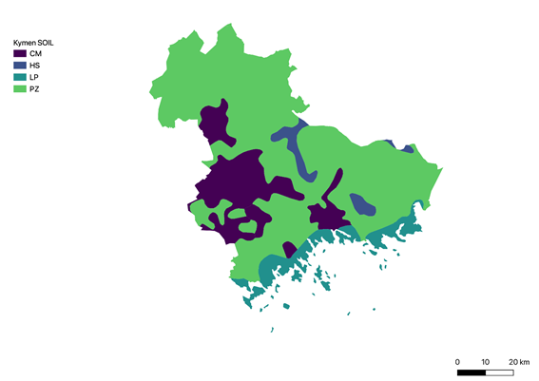

Figure 7. Soil types from European Soil Database (here Kymenlaakso).[3]

**Soil type analysis**

The spatial distribution and areas of different soil types can be identified using the European Soil Database Maps. The European Soil Database Maps follow FAO World reference base (WRB) soil classification. The WRB is a comprehensive classification system that enables accommodation of national soil classification systems. The WRB is not intended to be a substitute for national soil classification systems, but rather to serve as a common denominator for communication at the international level. The WRB comprises two levels of categorical detail: the first level having 32 Reference Soil Groups (RSGs); the second level, consisting of the name of the RSG combined with a set of principal and supplementary qualifiers (FAO, 2014).

Data on WRB level 1 spatial distribution can be used. Histosols are considered organic soils according to the IPCC guidelines, all other types of soils are classified as mineral.

More detailed definitions of the soil types can be found in the World reference base for soil resources guide (FAO, 2014).

**Combination of GIS data layers**

The administrative borders of the area in concern can be obtained for example from OpenStreetMap.

Datasets can be processed and analysed for example by utilising QGIS as follows: In the first step of GIS data processing all data layers are collected into a single GeoPackage (.qpkg). Each layer is projected according to the European Terrestrial Reference System (ETRS89). The administrative borders of the area of interest are utilised to clip the base layers (CORINE accounting layers, European Soil Database layers; Figure 3) isolating all the single features from each layer and respective areas (in m2) were calculated.

In the second step of GIS data processing, a relationship between land uses (extracted from CORINE land cover) and soil types (extracted from the European Soil Database) are set. The aim is to determine the total surface of a given land use, present on a certain soil type. For this purpose, the features from the European Soil Database can be utilised to clip the CORINE land cover layers (Figure 9). Doing so, a subset of land-uses that fall within each typology of soil is obtained. Once the soil types are associated with land uses, the land use analysis is ready.

**Inserting the results in the GGIA tool**

The GIS analysis described above has allocated the area in concern in six land use categories and two soil types. Once the analysis is done, the results can be repeatedly used in any land-use change quantifications utilizing the IPCC method.

Next planner needs to define the areas converted to another use category as a consequence of a plan or a policy. The land areas subject to change are measured in hectares and the result is inserted in the respective GGIA table.

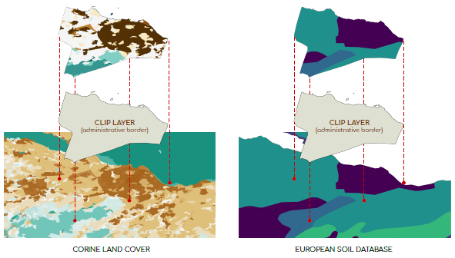

Figure 8. Example of GIS data processing (step 1).

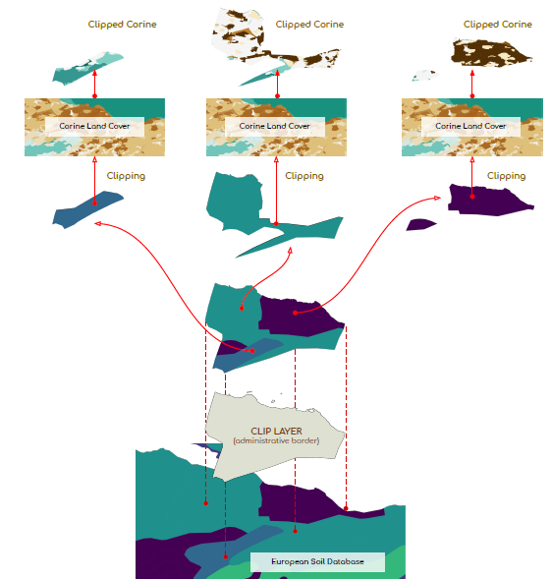

Figure 9. Example of GIS data processing (step 2).

## Energy use in buildings

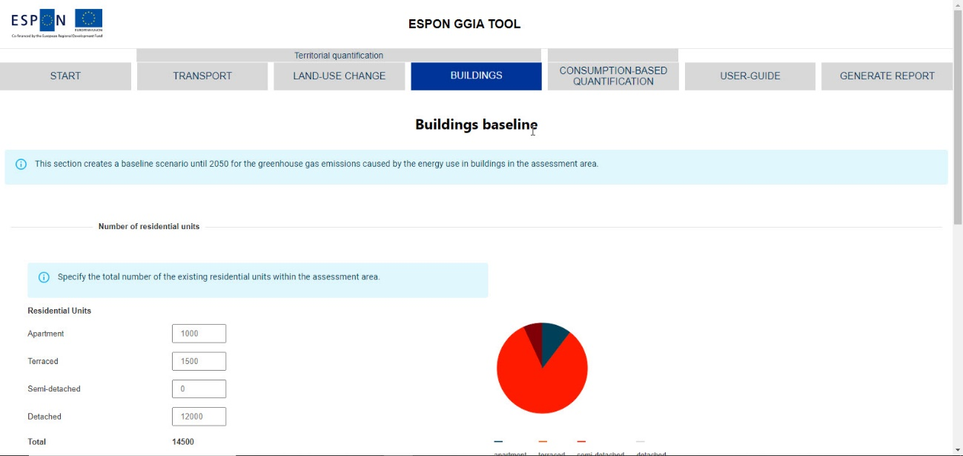

Figure 10. Buildings module.

In this section, “residential unit” refers to one dwelling. This is the basic unit for the inputs concerning residential building types. The quantities for commercial buildings are inserted in square meters (gross floor area).

### Buildings Baseline

This section creates a baseline scenario until 2050 for the greenhouse gas emissions caused by the energy use in buildings in the assessment area.

**Number of residential units**

Specify the total number of the existing residential units within the assessment area.

Apartment One dwelling in a residential multi-storey building is one unit.

Terraced One dwelling in a residential terraced building is one unit.

Semi-detached One dwelling in a semi-detached house is one unit.

Detached One detached house is one unit.

**Floor area of commercial buildings**

Specify the total gross floor area of the existing commercial buildings within the assessment area.

Retail

Health

Hospitality

Offices

Industrial

Warehouses

When all the inputs are done, please click **Submit**.

Click **Next** to see the baseline results.

**Baseline results**

After these inputs the tool provides a baseline scenario for the buildings GHG emissions within the assessment area. The baseline scenario presents the expected future development for the energy use in buildings. The sectoral future projection is based on the country-specific prognoses on

* Population change
* Decarbonisation of national grid electricity
* Zero annual demolition rate
* Zero annual new construction rate.

The default values for future projections are based on the EU Reference Scenario 2016 publication and the PRIMES modelling (Capros et al, 2016). The future projection does not include the impacts of local climate action plans. The current national scenario for grid electricity decarbonisation may differ from the default scenario. These assumptions can be revised in a local dataset.

Click **Next** to continue.

### Buildings policy quantification

The policies that can be quantified are new construction of residential units and/or commercial building, densification, building conversion as well as renovation policies for residential and commercial buildings.

#### New construction / densification

This section estimates the greenhouse gas emissions from the energy use in new buildings that are constructed according to the plan that is assessed.

**New residential units**

Insert the total number of new residential units according to the plan or policy that is assessed.

Apartment One apartment in a residential multi-storey building is one unit.

Terraced One apartment in a residential terraced building is one unit.

Semi-detached One apartment in a semi-detached house is one unit.

Detached One detached house is one unit.

Units completed between The first and the last year during which the new residents are moving in.

Energy from renewables Estimate the percentage of delivered energy that will be covered by local production of renewable energies. Renewable energy production for grid electricity is excluded.

**New commercial buildings**

Insert the total gross floor area of the new commercial buildings according to the plan or policy that is assessed.

New buildings completed between

Select the first and the last year during which these new buildings are taken in use.

% energy from renewables Estimate the percentage of delivered electricity that will be covered by local production of renewable energies. Renewable energy production for grid electricity is excluded.

**Densification**

In this section, the impact of planned new construction can be quantified through a densification rate of one specific part of the assessment area.

Number of existing units Insert the number of the existing residential units in the area that will be densified. This may be one specific part of the entire assessment area.

Densification rate Insert the volume of new construction as a percentage of existing units.

New residential units completed between

Select the first and the last year during which the new residents are moving in.

% energy from renewables Estimate the percentage of delivered energy that will be covered by local production of renewable energies. Renewable energy production for grid electricity is excluded.

Existing floor area Insert the existing floor area of commercial buildings in the area that is densified.

Densification rate Insert the volume of new construction as a percentage of existing floor area.

New buildings completed between

Select the first and the last year during which these new buildings are taken in use.

% energy from renewables Estimate the percentage of delivered electricity that will be covered by local production of renewable energies. Renewable energy production for grid electricity is excluded.

Click **Next** to continue.

#### Retrofit and renovation policies

This section quantifies the impact of retrofit and renovation policies on the greenhouse gas emissions.

**Retrofits of residential buildings**

This section quantifies the greenhouse gas impact of residential building retrofits/renovations.

Select residential unit Select the type of residential unit that will be retrofitted/renovated according to the plan/policy in assessment.

Number of units Insert the number of residential units that are retrofitted/renovated according to the plan/policy in assessment.

Indicative energy use before Estimate the energy consumption of existing residential buildings before retrofitting using the national energy certificate rating.

Indicative energy use after Estimate the energy consumption of existing residential buildings after retrofitting using the national energy certificate rating.

% energy from renewables Estimate the percentage of delivered energy that will be covered by local production of renewable energies. Renewable energy production for grid electricity is excluded.

Retrofits completed between Select the first and the last year of retrofitting.

**Retrofits of commercial buildings**

This section quantifies the greenhouse gas impact of commercial building retrofits/renovations.

Select building type Select the type of commercial building that will be retrofitted/renovated according to the plan/policy in assessment.

Total floor area Insert the total floor area of the commercial buildings that are retrofitted/renovated according to the plan/policy in assessment.

Reduction in energy demand Estimate the reduction in energy demand as a percentage. Positive percentage means an improvement of energy efficiency through retrofitting/renovation.

% energy from renewables Estimate the percentage of delivered energy that will be covered by local production of renewable energies. Renewable energy production for grid electricity is excluded.

Retrofits completed between Select the first and the last year of the retrofits.

**Change of building use**

This section quantifies the greenhouse gas impact caused by the changes of building use.

From Select the type of residential unit or commercial building for which the use will be changed according to the plan/policy in assessment.

To Select the type of residential unit or commercial building TO which the use will be changed according to the plan/policy in assessment.

Floor area Insert the total gross floor area for conversions

Conversions implemented Select the first and the last year when these changes in building use are carried out.

Click **Submit** to save the inputs.

Click **Next** to see the results.

### Buildings results

The graph shows the impact of the plans/policies on the GHG emissions. The dashed line presents the baseline scenario. If the policy quantification shows less emissions than the baseline scenario, the plan/policy reduces the GHG emissions.

Please notice that new residents always increase the absolute emissions. Per capita emissions can show improvements although the total GHG emissions would increase.

## Consumption-based calculation

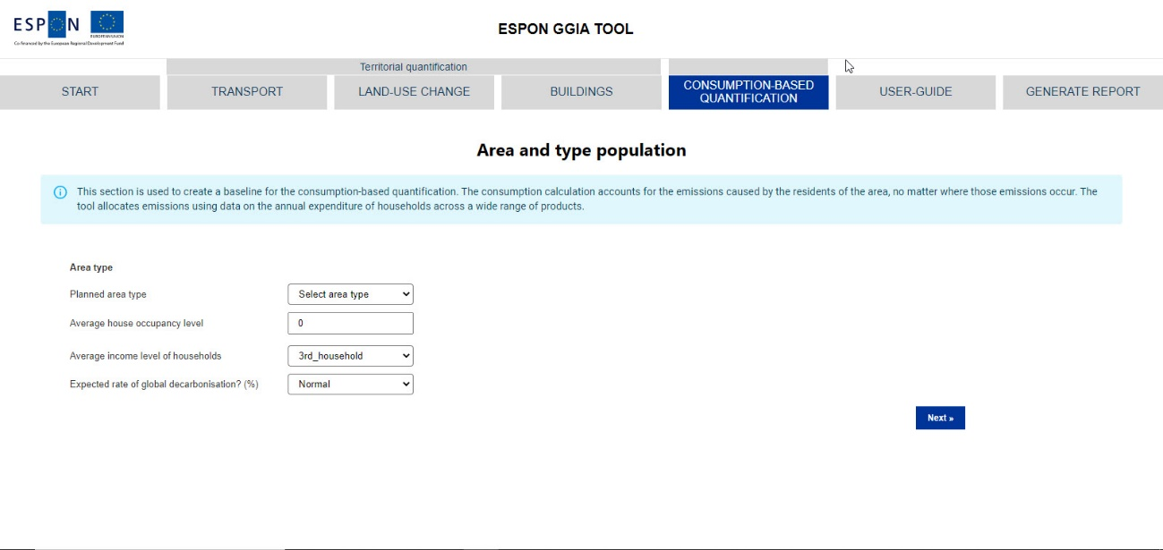

Figure 11. Specification of area type and population for the consumption-based quantification.

### Creating a baseline

**Area type and population**

**Area type**

**Planned area type** Select the best option to describe the area in assessment.

**Average house occupancy level**

Insert the average number of people per household.

**Average income level of households**

Select the best option to describe the income level in the assessment area.

**Expected rate of global decarbonisation**

Select the best option to describe the assumption on global decarbonisation rate.

Click **Next** to see the baseline results.

**Annual household emissions**

GGIA displays the baseline scenario as a graph and in total emissions until 2050.

### Household energy

**Policy implementation year**

Select: The year for which the policy should be implemented. This year should not be earlier than the year entered on the start page.

**New total population size**

Insert: The total number of residents expected by the policy implementation year (including existing residents)

**Construction**

Size of new residential buildings (gross SQM)

Insert: The total size in gross (square metres of floor space) of residential buildings expected as a result of the policy

**Household heating energy efficiency**

Click **Consider “Household energy efficiency”** if the policy can reduce heating or cooling energy.

% energy reduction of household heating & cooling

Insert: The percentage decrease in energy use for heating, cooling and hot water expected, averaged over each household in the area of interest (including both new and existing residents).

**Energy production**

Click **Consider local electricity production** if the policy includes new local production of renewable energy.

What is the source of local electricity production?

Select: The type of energy you would like to consider. It is expected that **Electricity by Solar photovoltaic** should be selected in most instances.

What % of demand is covered by this new source?

Insert: a percentage (0 - 100 %) for the amount of household electricity demand of the region (including both new and existing residents) that will be covered by the new electricity installation.

**Sustainable Heating**

Click **Consider changes in the heating share** if the policy can adjust the shares of heating energy.

What is the breakdown of heating sources in the area?

Here the user should choose the energy sources for household heating from three broad categories. Default values are shown as standard (specific for the country and urban type)

Insert:

District Heating: The percentage (0 - 100 %) of heating expenditure in the area (including both new and existing residents) for district heating

Electricity heating: The percentage (0 - 100 %) of heating expenditure in the area (including both new and existing residents) for electric sources (resistive heating and electric heat pumps)

Combustible Fuels: The percentage (0 - 100 %) of heating expenditure in the area (including both new and existing residents) for combustible fuels (such as natural gas).

These three values must sum up to 100 %

What is the breakdown of household fuel combustion?

Here the user should choose the types of combustible fuels used in the area (including both new and existing residents). Default values are shown as standard (specific for the country and urban type).

Insert: Liquid heating (combustible fuel): The percentage (0 - 100 %) of liquid fuels (e.g. heating oil) in the combustible fuels mix.

Solid heating (combustible fuel): The percentage (0 - 100 %) of solid fuels (e.g. wood) in the combustible fuels mix.

Gas heating (combustible fuel): The percentage (0 - 100 %) of gas fuels (e.g. natural gas) in the combustible fuels mix.

What are the direct emissions from district heating?

Insert: The emission factor for district heating in units of kg CO2 / euro. This should be in basic prices, which means any costs related to tax have been removed. It is likely that in many cases this value is not known. In such a case, 0 should be entered. This means the default value (specific for each country) will be used.

### Transportation

This page is used to enter any changes related to transport expected as a result of the policy.

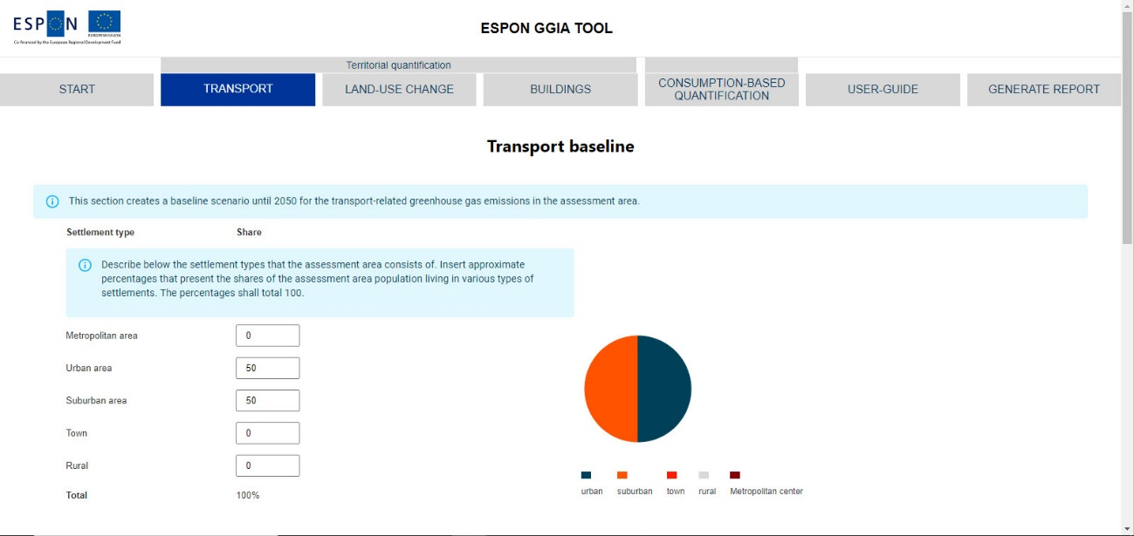

Figure 12. Transport-related inputs for consumption-based quantification.

**Biofuel in transport**

Click **Consider biofuel in transport** if the policy has an impact on biofuels.

What percentage of transport fuels are covered by biofuels?

Insert: The percentage (0 - 100 %) of biofuels used in private transport. If zero is entered, the default value (specific for each country) will be taken.

**Introduction of electric vehicles**

Click **Consider introduction of electric vehicles** if the policy can adjust their share in the vehicle fleet.

What percentage of private vehicles are electric?

Insert:The percentage (0 - 100 %) of private vehicles used by residents of the area (including both new and existing residents) that are electric. The tool assumes there are no electric vehicles to begin with, and so the default value is zero.

**Modal shift in transport**

Click **Consider transport modal shift** if the policy can adjust the modal shares (including both new and existing residents).

What percentage of private vehicle use is reduced?

Insert: the percentage by which private vehicle use is expected to reduce in the area. If private vehicle use is expected to increase, a negative value may be entered.

What percentage of private vehicle ownership is reduced?

Insert: the percentage by which private vehicle ownership is expected to reduce in the area. If private vehicle ownership is expected to increase, a negative value may be entered.

By what percentage is public transport use increased?

Insert: the percentage by which public transport use is expected to increase in the area. If public transport use is expected to decrease, a negative value may be entered.

Click **Next** to proceedto the Quantification results.

### Consumption-based quantification results

Three graphs are present on the consumption-based quantification results page.

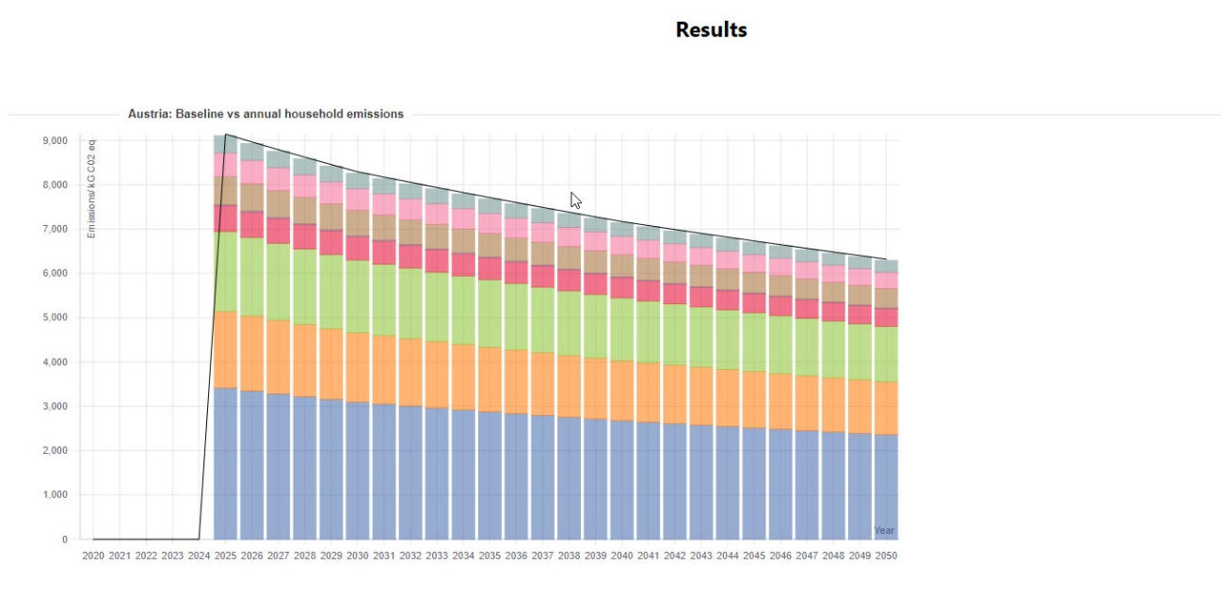

Figure 13. The first results graph, consumption-based quantification.

The first results graph (Figure 13) shows the impact of the plans/policies on the GHG emissions. The units are kgCO2e/(capita,a). Emissions are broken down into the same categories as on the baseline results page. The dashed line presents the total emissions under the baseline scenario. If the policy quantification shows fewer emissions than the baseline scenario, the plan/policy reduces the GHG emissions.

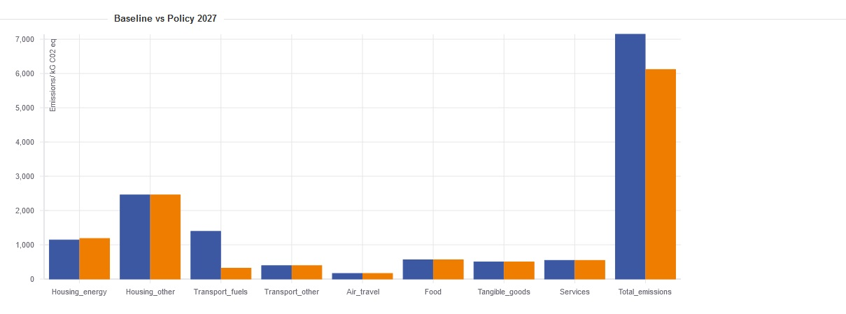

Figure 14. The second results graph, consumption-based quantification.

The second results graph (Figure 14) shows a bar chart comparing the baseline and the policy in the year of policy implementation. The units are kg CO2e/(capita,a). The baseline and policy emissions are shown in blue and orange, respectively. Results are broken down by the emissions sector and there is also a bar showing the total emissions. If the emissions are lower in the policy scenario, this can be seen from the total emissions bar. Construction based emissions are assigned to the year of the policy and are displayed together with the total emissions. If significant construction is planned as part of the policy, it is highly likely that the total emissions will be higher for the policy scenario than the baseline scenario in the year the policy is implemented. This is because construction is a significant source of emissions.

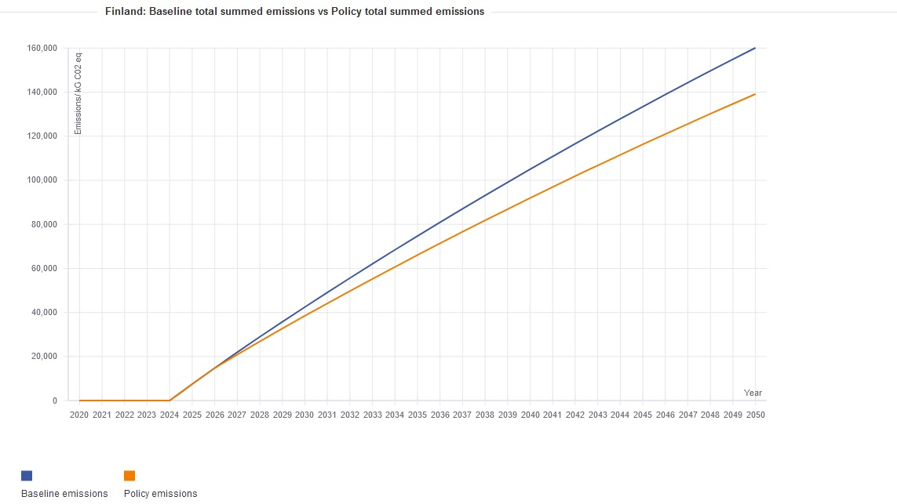

Figure 15. The third results graph, consumption-based quantification.

The third results graph (Figure 15) shows the total emissions that have occurred up to a given year for both the baseline and policy, respectively. This means that for each year it adds together all the emissions that have occurred in previous years together with the emissions for that year. The baseline emissions are shown in blue and the policy emissions in orange. The units are kgCO2e/capita. This allows the user to see whether the enacted policy has reduced total emissions by 2050 or not. If this is the case, the orange curve will be below the blue curve. If there are substantial construction emissions, the orange curve may be temporarily above the blue curve, but be lower by 2050. An example of such a situation is given below (Figure 16). In other cases, the emissions from construction may be so large that the total emissions for the policy scenario are still greater than the baseline scenario, even by the year 2050.

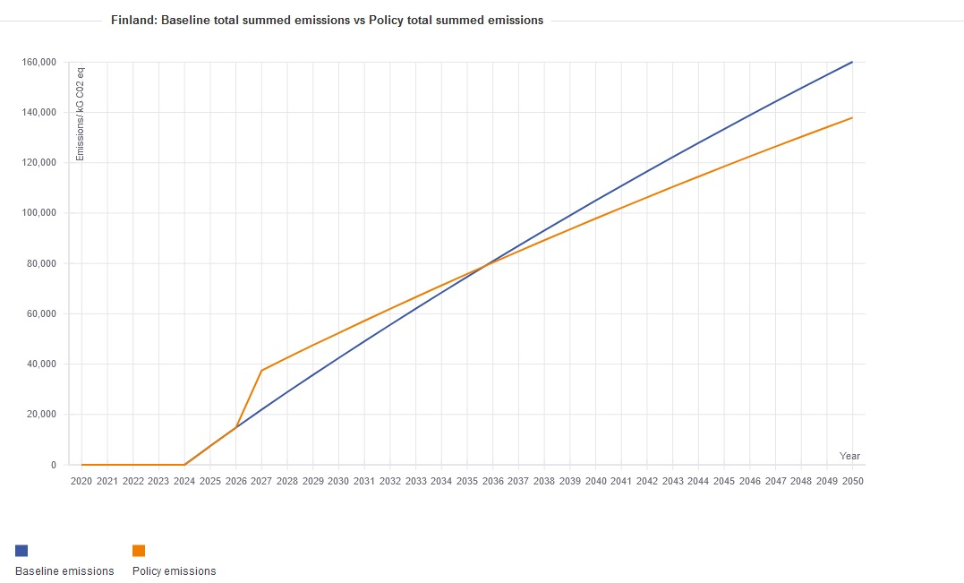

Figure 16. Example of results graph with construction emissions in 2026.

## Generate report

### Results of territorial quantification

The territorial quantification results present the greenhouse gas emissions from transport, land-use change and energy use in buildings within the assessment area from the baseline year to 2050. The future trajectory includes the impact of other existing measures only if they are inserted through the local dataset. The dashed line shows the baseline projection and the bar chart displays the impacts of the plan/policy that is assessed with the GGIA tool.

The results are announced below in two different units. The upper graph presents the absolute greenhouse gas emissions within the area. The lower graph presents the results as tonnes of CO2/per capita.

Please notice that although it is a common practise to announce the territorial greenhouse gas emissions per capita, they are not caused by the residents only.

### Results of consumption-based quantification

The consumption-based quantification estimates the global greenhouse gas emissions caused by the all consumption of the residents of the assessment area from the baseline year until 2050. The dashed line shows the baseline projection and the bar chart displays the impacts of the plan/policy that is assessed with the GGIA tool. The results are announced as tonnes of CO2e/capita.

### How to read the results?

The dashed line shows the baseline projection and the coloured bar chart displays the impacts of the plan/policy that is assessed with the GGIA tool. Higher deviation means higher impact on the greenhouse gas emissions reductions within the area in assessment.

The two quantification approaches provide two important perspectives on the greenhouse gas emissions.

Territorial results reflect the impact of a plan/policy within the geographic boundary of the specific area. The changes in land use and in the volume of building stock are directly defined in spatial planning. In transport, the impacts of planning is more complex, as the passenger transport by non-residents and the freight transport may be less affected by local policies.

Consumption-based results are about the residents of the area, reflecting the life styles and the consumption of the households, providing a holistic picture on the global greenhouse gas emissions.

### How to continue with the process?

The policy quantification section can be revisited to calculate the impact of alternative policies. The same baseline serves also these quantifications. Several sectoral impacts can be quantified simultaneously, but the possible interdependencies are not taken into account.

# Quantification examples – Planner User

## Reverse use

The GGIA tool can be used to identify those parameters that have a major impact on the GHG emissions within the area in assessment.

To this end, various parameters can be adjusted in order to define the changes that can radically reduce the GHG emissions. When the user has identified some parameters that can make a major difference, it is possible to start developing planning policies and other measures to enhance the desired development. Here the percentages inserted in the tool become also indicators that can be monitored: for example the modal share may have a long-term target and the impact of a policy can be evaluated and monitored annually by producing updates on modal share through questionnaires and traffic counts.

## Comparison of policy impacts

The GGIA tool enables comparison of policy impacts: for example the modal split of Freiburg, Germany can be inserted into the tool, together with the local baseline, to estimate the impact on the GHG emissions. The same policy measure is likely to have different kind of impacts in each new context.

## New zero energy settlement

The GHG emission reduction potential of zero energy construction depends on the definition that is applied.

The most common definition for this kind of buildings is **net zero energy**, which means that the annual balance of purchased energy (delivered energy) and the renewable energy delivered into the electricity grid (or district heating network) is zero. If the amount of exported energy exceeds the purchased energy, building can be called **a net plus energy building**. A net zero energy (or net plus energy building) is typically very energy-efficient building, for example a passive house or A-rated buiding, which is equipped with a large solar energy system. Part of the solar energy is used directly in the building, where it reduces the need for purchased energy during the sunny season. The building generates excess electricity to the grid especially during the peak hours, but is dependent of the grid electricity, especially during the winter season.

The GGIA tool automatically assumes that new construction is A-class. The share of energy consumption covered from renewable energies expresses how large share of the annual energy consumption can be covered with own production. Due to the mismatch problem described above, this value is not 100% in a net zero energy building: more realistic assumption is 25%–40%.

If you set this percentage to 100%, the new buildings can be called **off-grid zero energy buildings**, that can operate without any energy from outside the plot boundary. This kind of buildings are quire rare, and require major investments on the solar energy system on the plot or in the vicinity of buildings. Please notice that if a building is heated with wood that comes from outside of the plot boundary, it may not be considered entirely off-grid. In this case the source of heating energy is wood, and the renewable energy percentage is >50%, depending on the location.

Please notice that the surplus energy that these buildings feed into the grid has no impact on the GHG quantification result. In the scale of electricity grid, the input of a single building is small, and we assume that it will have no impact on the electricity production systems that are responsible for electricity production. If really large amounts of buildings will start producing electricity for the grid, it may decrease the grid electricity emission factor. This benefit depends on how the grid electricity is produced and how much there is power capacity that can be adjusted during the peak hours of solar energy production.

Please notice that although these impact can be tested, the GGIA tool is not designed to display the impacts of specific building solutions, but rather reflect the impact of planning policies that may drive the average energy consumption of buildings in a desired direction.

Inputs in GGIA:

Insert the number of new units (or new floor area in case of commercial buildings).

Adjust the percentage „share of energy consumption from renewable energies“.

The positive impact will be displayed in the results announced as GHG emissions per capita. In absolute GHG emissions, new construction means always increase of emissions.

Please notice that in many countries „**nearly zero energy**“ actually refers to the building code minimum requirement. For this, leave the value for renewable energy zero.

When implementing a zero energy construction policy, please check what are the opportunities and limitations of national regulation for steering the new construction beyond the building code requirement. If this policy is intended to be applied as a obligatory, it is important to specify how net zero energy balance is verified. Typically, this is based on design stage calculation according to the building code guidelines. The real energy consumption and solar energy generation may differ from the calculation result, and in reality there will be variation in the annual energy balance of net zero energy buildings, depending on the weather and the use of the building. The life span of photovoltaic systems is approximately 25 years, so after this period the impact of this policy may decline, as there are no verification methods.

Please notice also that large solar energy systems have an impact on the cityscape. Typically, having enough photovoltaic panel surface area for an annual net zero balance is easier in low buildings (single family houses etc) than multi-storey houses, as the roof surface area in relation to the floor area is larger.

For major electricity output, wind turbines would need to be rather big, and it is difficult to built large wind turbines close to residential areas. The impact of wind turbine investments outside the plot boundary can also be analysed with the GGIA tool, but in practise this usually requires some kind of local subgrid or energy community utilizing wind energy locally. In this case, adjust the renewable energy percentage for all the buildings that are connected to the sub grid. Please notice that this electricity can also charge electric vehicles within the area. The transport module enables respective adjustments regarding the share of renewable energy.

# Local Datasets – Expert User

Local dataset provides an opportunity to adjust the county-specific default data and apply the most accurate and relevant data available in the quantification. This is an opportunity for an expert user who has good knowledge on greenhouse gas quantification and the collection of both activity data and emission factors.

Local datasets are region-specific datasets for their respective modules. Creating it requires quite a bit of domain knowledge and expertise. For the territorial quantification modules we provide an excel table to test and develop this data. The process for the consumption module is more complex and described below.

In both cases the region specific local dataset needs to be exported as a csv file and added to <https://github.com/QGasSP/ggia-backend/tree/main/CSVfiles> (in a respective fork of the repository - a pull request can be made to make this data available to the community). Datasets go into the datasets folder in *CSVfiles*. Datasets for consumption go into *consumption/datasets*. When the frontend container is restarted the datasets are detected and are provided as a choice (under Local Dataset) on the Start page.

## Local dataset for territorial quantification

The local dataset for the territorial quantification can be created in two ways:

* in MS Excel files that can be downloaded from the GitHub

GGIA_local_dataset_T (writes a local dataset for territorial quanfication)

GGIA_local_dataset_C (writes a local dataset for consumption-based quantification).

* in the browser-based tool itself, by choosing **Create local dataset** on the start page (territorial dataset only).

These tools write a csv dataset that the GGIA tool can utilize. Chapter 4.3 explains how a new dataset can be submitted to ESPON EGTC in order to have a new dataset uploaded in the GGIA tool where it is available for all users of the tool.

Working on a MS Excel file may be practical because local dataset contains a lot of site-specific expert information and it is a time-consuming process to collect the best available data. A local dataset for consumption-based quantification can only be done with the MS Excel template provided. Here the tool default values are not useful as a new local dataset requires a household budget survey (HBS) that provides an all-inclusive dataset for the purpose.

The local dataset function is designed for **Expert user**. This requires experience in GHG quantification that is needed in collecting relevant local data. Any suitable data collected for a recent local GHG inventory can be utilized here.

Please notice that this data includes also future scenarios. By default, the national scenarios are based on PRIMES modelling (Capros et al, 2016) that do not include any climate action taken after 2015 or sub-national climate policies. The local datasets can apply the most relevant scenarios. Future scenarios are inserted as annual change percentages, for example:

* If the CO2e emission factor for grid electricity is expected to be 2% lower in 2025 than 2024, insert -2.0 in cell 2025.
* If the bus transport (in passenger-km/a) is expected to be 1.3% higher in 2029 than 2028, insert 1.3 in cell 2029.

Respectively, all future scenarios are inserted year by year as expected annual change percentages.

### Creating a local dataset for territorial quantification with the Excel tool

A local dataset for territorial quantification can be created with an Excel tool called **GGIA_local_dataset_T**. The Excel file can be downloaded from the GGIA GitHub site. It includes the territorial calculation modules of the GGIA tool as well as the default datasets of the GGIA tool.

After opening of the tool, please click **Create a new local dataset** button in the navigation ribbon of the Start worksheet. This opens a new worksheet where all the inputs for a new local dataset can be done.

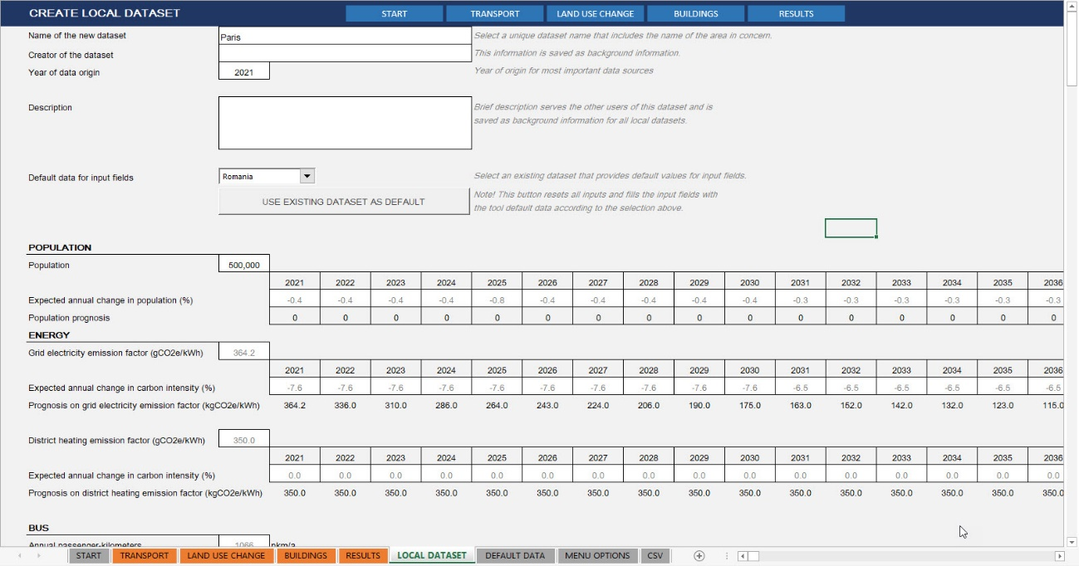

Figure 17. Creating a local dataset in the Excel tool.

The key inputs expected from expert user are explained below.

Name of the new dataset Insert: Provide a unique name for the dataset. This will be displayed in the menu options, so the name should be informative, for example “Tallinn” or “Kymenlaakso”.

Creator of the dataset Insert: Please write the name of the organisation who created the dataset. This will be saved as background information for the dataset.

Year of data origin Insert: Please specify here the year of origin for the most important data sources. This number will be later used to evaluate whether the dataset is up-to-date.

Description Insert: Please describe the dataset with 1–3 sentences, for example: “*This dataset is based on the information collected for the 2017 and 2018 baseline inventories as disclosed via the Carbon Disclosure Project. The methodology applies BEIS datasets which give transport data at a local authority level. Land use emissions have been lifted from UK local authority and regional carbon dioxide emissions national statistics: 2005 to 2019. This methodology is described in detail in https://assets.publishing.service.gov.uk/government/uploads/system/uploads/attachment_data/file/996062/lulucf-local-authority-mapping-report-2019.pdf.”*

Default data for input fields Select: The closest reference to the area in concern among the existing datasets in the GGIA tool. This can be either a country or another local dataset.

The input fields can be first automatically filled with the default values from existing GGIA datasets. If some local data cannot be provided, default values can be kept instead and saved in the local dataset.

For example, when creating a local dataset for the city of Tallinn, a useful default dataset would be “Estonia”. The input fields are first filled with Estonian dataset values that serve as defaults. When expert user starts filling in the Tallinn data, he/she is expected to replace the Estonian data with more accurate, Tallinn-specific values in as many input fields as possible.

Use existing dataset as default This action button places the default values in all the input fields of the Local dataset worksheet. Please notice that any previous inputs cannot be recalled after pushing this button.

POPULATION

Population Insert the population of the area

Expected annual change Insert the population prognosis for the area in concern in percentages for annual change. The tool calculates the average annual change per decade and saves this information in the dataset.

ENERGY

Grid electricity emission factor Insert the local CO2e emission factor (gCO2e/kWh) for grid electricity in 2021.

Expected annual change Insert the relevant scenario for grid electricity emission factor as annual change percentage.

District heating emission factor Insert the local CO2e emission factor (gCO2e/kWh) for district heating in 2021.

Expected annual change Insert the relevant scenario for district heating emission factor as annual change percentage.

BUS

Annual pkm per capita Insert the annual passenger-kilometers per capita (pkm/(capita, a) for bus transport.

Average bus occupancy Insert the average bus occupancy rate.

Expected annual change Insert the prognosis (increase/decrease) in passenger-kilometers per capita for bus transport as annual change percentage.

Engine types in bus transport

Column % Insert the shares of engine types (fuel types) in the bus fleet that operates within the area in concern.

Here calculation applies a simplification: The calculation should actually ask for shares for kilometres driven with different types of bus engines within the area. However, this kind of data is rarely available. Thus, the tool assumes that the kilometres driven with various engine types within the area correlate with the shares of engine types in the bus fleet.

EFs for driving on streets Insert the CO2e emission factor (EF) per vehicle-km (gCO2e/vkm) for each engine type in street driving.

EFs for driving on roads Insert the CO2e emission factor per vehicle-km (gCO2e/vkm) for each engine type in road driving.

In many sources CO2e emission factors are defined for three types of driving: street driving, road driving and highway driving. This tool does not apply highway driving but considers that as road driving. The driving profiles are defined for various types of settlements by defining a ratio between street driving and road driving.

The CO2e emissions for street driving tend to be significantly higher than for road driving, due to frequent stops and acceleration.

If the emission factors for street driving and road driving are not available, it is also possible to insert the same factor for both street and road columns per each fuel type. In this case, the calculation will not not able to make a difference between the driving profiles in various kinds of environments, and the user inputs on the settlement type will have no impact on car, bus and road transport emissions. Territorial GHG inventories are often done this way.

Driving profile for settlement type

(%) road driving/street driving Insert the share of road driving in metropolitan areas, urban areas, suburban areas, towns and rural areas. The tool calculates the share of street driving automatically. With these percentages and the emission factors described above, driving profiles and emission factors are defined for the five settlement types.

CAR

Annual pkm per capita Insert the annual passenger-kilometers per capita for car transport.

Average car occupancy Insert the average bus occupancy rate.

The country-level default data in the tool origins from the TRACCS project dataset that covers all countries included in the tool.

The car occupancy rates vary between urban and rural areas, but this aspect has been excluded from the calculation as this kind of data are in most cases not available.

Expected annual change Insert the prognosis (increase/decrease) in passenger-kilometers per capita for car transport as annual change percentage.

Engine types in car transport

% Insert the shares of engine types (fuel types) in the car fleet that operates within the area in concern.

Here calculation applies a simplification: The calculation should actually ask the shares by kilometres driven with different types of car engines within the area. However, this kind of data is rarely available. Thus, the tool assumes that the kilometres driven with various engine types within the area correlate with the shares of engine types in the car fleet.

If the car kilometres driven in the area can be divided between the car fuel types, those percentages can be inserted here, and the accuracy of the calculation is improved.

EFs for driving on streets Insert the CO2e emission factor (EF) per vehicle-km (gCO2e/vkm) for each engine type in street driving.

EFs for driving on roads Insert the CO2e emission factor per vehicle-km (gCO2e/vkm) for each engine type in road driving.

In many sources CO2e emission factors are defined for three types of driving: street driving, road driving and highway driving. This tool does not apply highway driving but considers that as road driving. The driving profiles are defined for various types of settlements by defining a ratio between street driving and road driving.

For internal combustion engines (ICE), the CO2e emissions for street driving tend to be significantly higher than for road driving, due to frequent stops and acceleration.

If the emission factors for street driving and road driving are not available, it is also possible to insert the same factor for both street and road columns per each fuel type. In this case, the calculation will not not able to make a difference between the driving profiles in various kinds of environments, and the user inputs on the settlement type will have no impact on the car transport emissions. Territorial GHG inventories are often done this way.

Driving profile for settlement type

(%) road driving/street driving Insert the share of road driving in metropolitan areas, urban areas, suburban areas, towns and rural areas. The tool calculates the share of street driving automatically. With these percentages and the emission factors described above, driving profiles and emission factors are defined for the five settlement types.

METRO

Annual pkm per capita Insert the annual passenger-kilometers per capita for metro transport.

Sometimes only one part of the metro network is inside the boundaries of the area. In this case the annual passenger-kilometers should be estimated for the track length within the area boundary. To this end, the track length within the area can be measured for example in Google maps.

Average metro occupancy Insert the average metro occupancy rate.

Expected annual change Insert the prognosis (increase/decrease) in passenger-kilometers per capita for metro transport as annual change percentage.

Metro systems included Name here the metro lines within the area in assessment.

Million pkm/a Insert here passenger-kilometers per year for each metro line included (million passenger-kilometres/year). If the assessment are is large and includes many cities with their municipal metro networks, one line can be allocated for one city.

Metro transport can be also inserted as one figure on row one.

If there are no metro lines in the assessment area, please insert zero to the “annual pkm per capita” and leave the fields for metro systems empty.

TRAM

Annual pkm per capita Insert the annual passenger-kilometers per capita for tram transport.

Sometimes only one part of the tram network is inside the boundaries of the area. In this case the annual passenger-kilometers should be estimated for the track length within the area boundary. To this end, the track length within the area can be measured for example in Google maps.

Average tram occupancy Insert the average tram occupancy rate.

Expected annual change Insert the prognosis (increase/decrease) in passenger-kilometers per capita for tram transport as annual change percentage.

Tram systems included Name here the tram lines within the area in assessment.

Million pkm/a Insert here the passenger-kilometers per year for each tram line included (million passenger-kilometres/year). If the assessment are is large and includes many cities with their municipal tram networks, one line can be allocated for one city.

Tram transport can be also inserted as one figure on row one.

If there are no tram lines in the assessment area, please insert zero to the “annual pkm per capita” and leave the fields for tram systems empty.

PASSENGER TRAIN

Annual pkm per capita Insert the annual passenger-kilometers per capita (pkm/(capita, a) for passenger transport on rails.

Average train occupancy Insert the average train occupancy rate.

Emission factor, diesel train Insert the average emission factor per train-km for a train with diesel engine (gCO2e/train-km).

Electricity cons, electric train Insert the average electricity consumption per train-km for electric engine (kWh/train-km). In the GHG emissions quantification, the tool will apply the grid electricity emission factor announced in the local dataset.

Share of electric engines Insert the share of electric engines in train fleet.

This is a simplification: if possible, announce the share of electric engines in total annual train-kilometres driven in the area.

The share of diesel engines is calculated automatically, assuming that there are no other alternatives for locomotive propulsion.

Expected annual change Insert the prognosis (increase/decrease) in total passenger-kilometres per capita for passenger train transport within the area as annual change percentage.

FREIGHT ON RAILS

Annual vkm per capita Insert the annual vehicle-kilometers per capita (vkm/(capita,a) for freight transport on rails.

Emission factor, diesel train Insert the average emission factor per train-km for a train with diesel engine (gCO2e/train-km).

Electricity cons, electric train Insert the average electricity consumption per train-km for electric engine (kWh/train-km). In the GHG emissions quantification, the tool will apply the grid electricity emission factor announced in the local dataset.

Share of electric engines Insert the share of electric engines in train fleet.

This is a simplification: if possible, announce the share of electric engines in total annual train-kilometres driven in the area.

The share of diesel engines is calculated automatically, assuming that there are no other alternatives for locomotive propulsion.

Average load Insert the average load in train transport.

Expected annual change Insert the prognosis (increase/decrease) in total passenger-kilometres per capita for passenger train transport within the area as annual change percentage.

FREIGHT ON ROAD

Annual vkm per capita Insert the annual vehicle-kilometers per capita (vkm/(capita,a) for road freight transport.

Average load Insert the average load in road freight transport.

Expected annual change Insert the prognosis (increase/decrease) in passenger-kilometers per capita for road freight transport as annual change percentage.

Engine types in road freight transport

% Insert the shares of engine types (fuel types) in the lorry fleet that operates within the area in concern.

Here calculation applies a simplification: The calculation should actually ask the shares by kilometres driven with different types of lorry engines within the area. However, this kind of data is rarely available. Thus, the tool assumes that the kilometres driven with various engine types within the area correlate with the shares of engine types in the lorry fleet.

If the lorry kilometres driven in the area can be divided between the fuel types, those percentages can be inserted here, and the accuracy of the calculation is improved.

EFs for driving on streets Insert the CO2e emission factor (EF) per vehicle-km (gCO2e/vkm) for each engine type in street driving.

EFs for driving on roads Insert the CO2e emission factor per vehicle-km (gCO2e/vkm) for each engine type in road driving.

For internal combustion engines (ICE), the CO2e emissions for street driving tend to be significantly higher than for road driving, due to frequent stops and acceleration.

If the emission factors for street driving and road driving are not available, it is also possible to insert the same factor for both street and road columns per each fuel type. In this case, the calculation will not not able to make a difference between the driving profiles in various kinds of environments, and the user inputs on the settlement type will have no impact on the road transport emissions. Territorial GHG inventories are often done this way.

Driving profile for settlement type

(%) road driving/street driving Insert the share of road driving in metropolitan areas, urban areas, suburban areas, towns and rural areas. The tool calculates the share of street driving automatically. With these percentages and the emission factors described above, driving profiles and emission factors are defined for the five settlement types.

FREIGHT ON INLAND WATERWAYS

Annual vkm per capita Insert the annual vehicle-kilometers per capita (vkm/(capita,a) for freight transport on inland waterways.

Emission factor, average Insert the average emission factor to be applied for all freight transport on inland waterways (gCO2e/vkm).

Average load Insert the average load in freight transport on inland waterways.

Expected annual change Insert the prognosis (increase/decrease) in total annual transport activity (vehicle-kilometres per capita) for freight transport on inland waterways within the assessment area as annual change percentage.

LAND-USE AND LAND-USE CHANGE

LAND USE

If a previous GHG inventory for the assessment area exists, this table provides an opportunity to insert it in the tool. A land-use baseline cannot be estimated in the GGIA tool for two reasons:

* The focus of the tool is in quantifying the impacts of spatial planning and planning policies. These impacts are included in the module Land-use change.
* A proper land-use GHG analysis is a complicated process, for which data has to be collected from a number of sources. Having land-use baseline analysis included in every study would make the tool use very complicated and time-consuming and most likely less attractive for planner users.

If land-use baseline would need to be included and no previous inventory is available, Annex 2 describes a simplified method for the quantification land-use emissions, utilizing European data.

Land use – baseline Insert the results of the previous inventory for the six IPCC land use categories.

The future scenario on land-use emissions is converted into annual change percentages per decade and saved in the local dataset in this format.

LAND-USE CHANGE

Carbon stock change factors Insert the carbon stock change factors (tC/(ha,a) that the tool will use to quantify the land-use change.

The national default values in the GGIA tool are collected from the CRF (common reporting format) tables of national inventory reports (NIR, inventory year 2019), except the factor for deforestation which origin from a FAO report (FAO, 2020). Figure 18 below shows one example of NIR CRF table providing carbon stock change (CSC) factors for one country. The carbon stock change factors are announced in the middle section (columns for net change in living biomass, dead organic matter, mineral and organic soil).

Many territorial inventories apply national CSC factors, thus the national default values of the GGIA tool may be applicable also for local datasets.

Please notice that the NIR CFR tables do not provide factors for all land-use changes. If the CSC factor cell is empty, calculation shows zero impact for this type of land-use change.

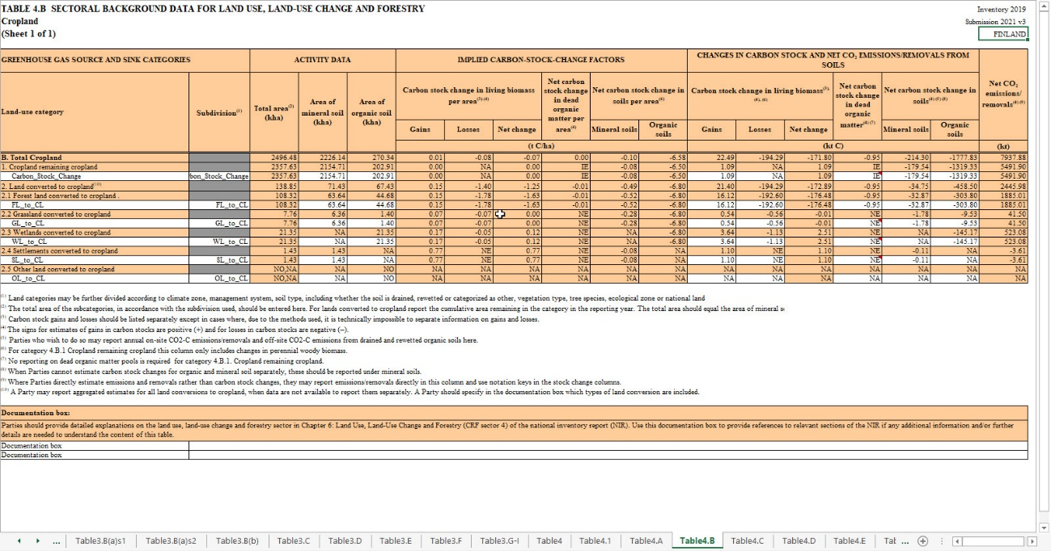

Figure 18. A source for CSC factors, example (NIR Finland, Table 4.B, Inventory year 2019).

BUILDINGS

Naming

Residential Please name here four building types that the tool operates with.

The tool default values for building types are

* + - Apartment
    - Terraced
    - Semi-detached
    - Detached.

Commercial The tool default values for commercial buildings are

* + - Retail
    - Health
    - Hospitality
    - Offices
    - Industrial
    - Warehouse.

Any category can be renamed to make them more relevant for the users. For example terraced houses are very rare in Finland, but row houses are very common and this taxonomy is applied also in Finnish statistics.

Please notice that if you change the building categories, all calculations will be carried out using these categories, and you will have to be able to provide emission factors for these all building types in the local dataset. The number of building types cannot be changed without editing the code and the data structure.

Emission factors Insert the CO2e emission factors (gCO2e/kWh) for energy carriers.

If the assessment area includes several district heating networks with different emission factors, a weighted average can be applied here.

Future changes in building stock

Insert the expected annual increase/decrease as annual change percentage.

For example, if the annual increase for A-rated apartments is 2%, it means that the number of new apartments (with A-rating in energy certificate) constructed during one year is expected to be 0.02 x number of existing apartments in the area in previous year.

The national default values of the GGIA tool are zero, as no future prognosis provides detailed information that would cover all ten building types in the 32 countries of the tool. With this assumption, building stock would remain the same.

Floor area per residential unit Insert average floor areas per residential unit (m²/dwelling). Residential unit = dwelling.

Average total energy use Insert average total energy use (kWh/dwelling).

End use of energy Insert the shares of end energy use (%) for

* + - * + Heating of spaces
        + Heating of water
        + Lights and appliances
        + Pumps and fans.

The percentages should sum up 100.

Average energy consumption Insert the energy consumption for residential unit types (dwellings) and commercial building types by energy carrier:

* Electricity
* Gas
* Oil
* Coal
* Peat
* Wood
* Renewable
* Heat.

Create Excel dataset This button adds a new local dataset option in this Excel file. It will be saved on your local computer as you save the whole file before closing the program.

Create CSV dataset This button creates a new dataset for the browser-based GGIA tool as a csv file and saves it on the same folder where this MS Excel file is saved.

### Creating a local dataset for territorial quantification in the GGIA tool

The local dataset writer can be opened from the Start page. First click the **Start** button to enter the page where the basic information for a new project is provided. Here you can find the button **Create local dataset** that will start the process.

The inputs in the GGIA tool are exactly the same than in the Excel tool.

## Local dataset for consumption-based quantification

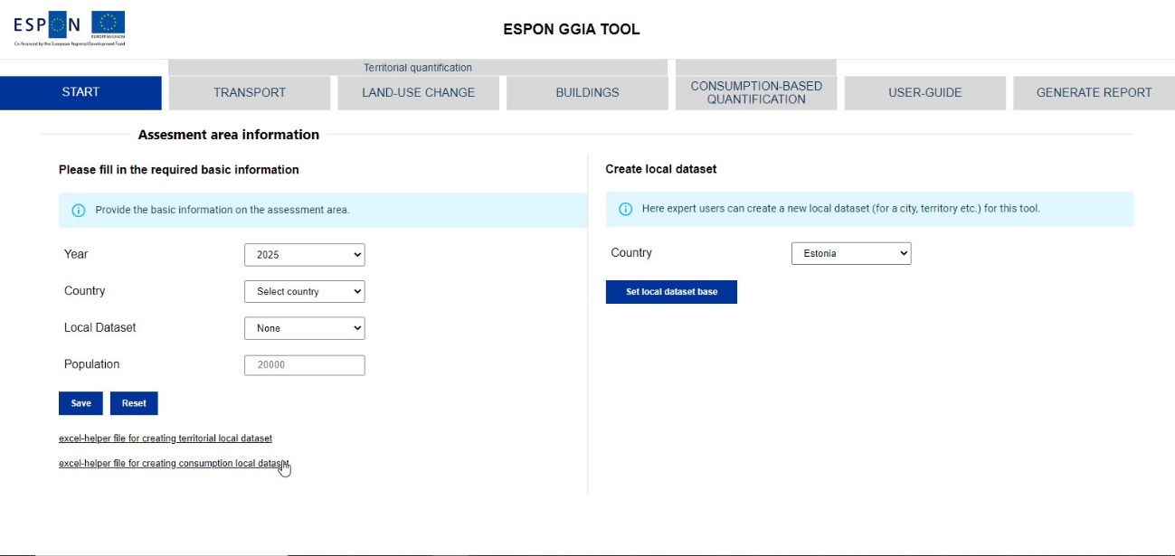

Figure 19. Local dataset creation in the GGIA tool.

The local data set for the consumption-based emissions should be composed from a local household budget survey (HBS). This describes how much an average household in the region of interest spends on a variety of different products in a single year. This means a HBS should be conducted for the local region. In total, there are 63 categories in the HBS used by the tool. The categories follow the Classification of Individual Consumption by purpose (COICOP), set out by the United Nations statistics division. Care should be taken to ensure the HBS is representative of the residents of the region under consideration and that the sample size is sufficient. Appropriate statistical processing steps may also be needed.

Once complete, the values from the HBS may be entered into an excel template (**GGIA_local_dataset_C.xls** in GitHub) to convert them into values suitable for the tool. This process is described below (and the in Excel file) using example data for Austria. This data is included in the data template and should be overwritten by the equivalent local data. The associated emission factors are set at the country level and remain unchanged in the local data set.

**Sheet 1: HBS_formatting**

The user should enter the results from the HBS into the right side column (C) under the title “Initial HBS” on the ‘HBS_formatting’ worksheet (Figure 20). Care should be taken to confirm the products are entered in the correct order. Next, the user needs to convertthe results from purchaser to basic prices. This means that the value of any taxes, levies or subsidies should be removed from the expenditure. For each product, the user should provide a scale factor to convert between purchaser and basic prices. This data should be entered into the right side column under “basic prices vector” (H). Finally, inflation must also be considered for each product. A second set of scale factors should be entered into the right side column (L) under the title “inflation vector”, describing the changes in prices that have occurred between the year the HBS was conducted and 2020. If the HBS was conducted after 2020, then most of these values are expected to be less than 1. The information necessary to convert the original HBS to 2020 basic prices may be available on Eurostat. For example, the database NAIO_10_CP15 can be used to convert between basic and purchaser prices. Inflation data can be found using the database PRC_HICP. Other sources could also be used to transform the data.

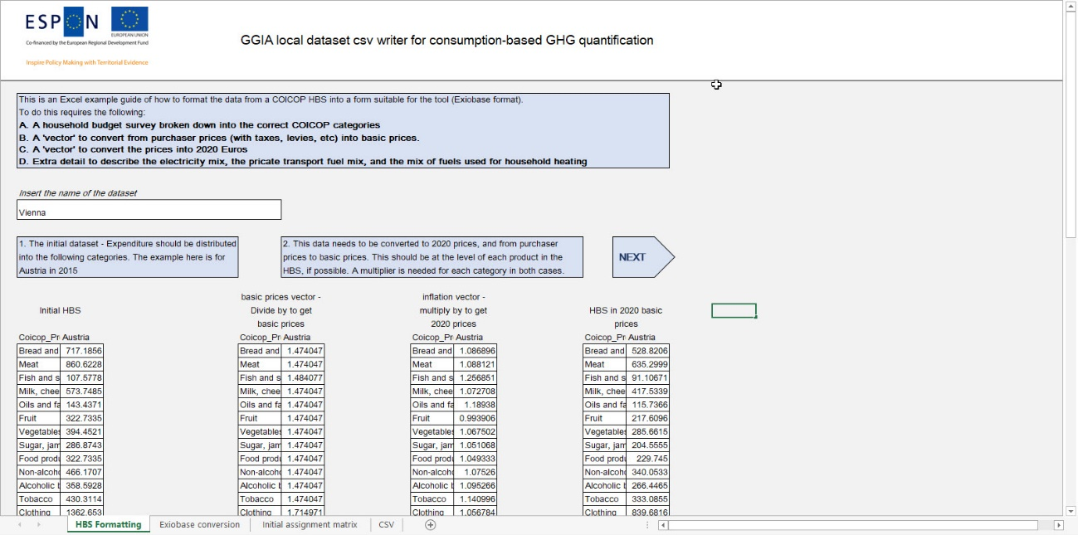

Figure 20. HBS data applying the COICOP classification by UN.

The final data should be available in the last column (O) once the necessary data has been entered.

**Sheet 2: Exiobase conversion**

The user should then proceed to the ‘Exiobase conversion’ sheet (Figure 21) by clicking “Next” or the “Exiobase conversion” button in the navigation ribbon. Here, the data will have already been converted into a format suitable for the tool and is available in the middle column (C) under the title “Exiobase format”.

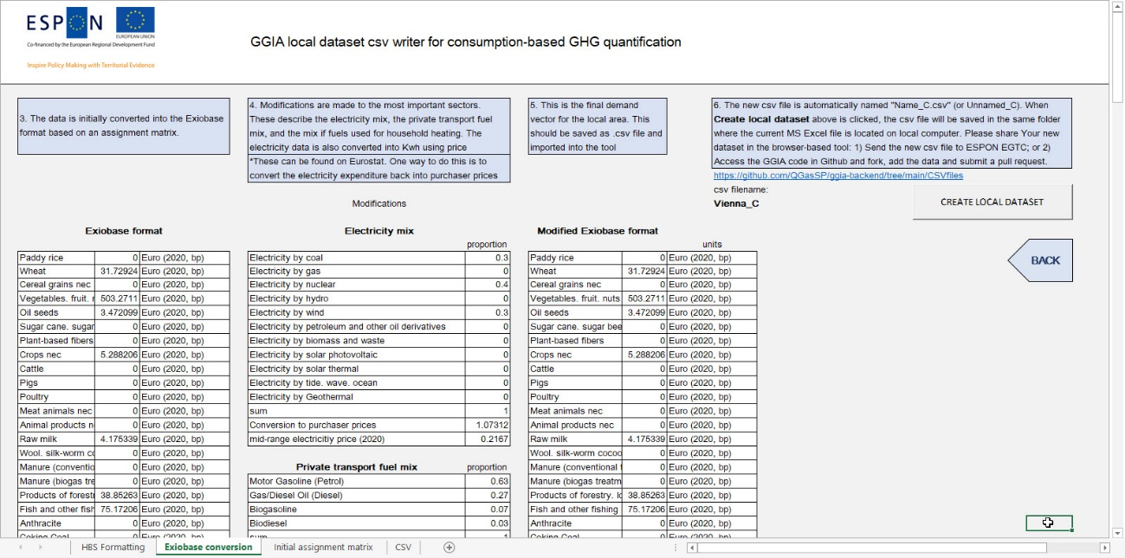

Figure 21. Exiobase conversion worksheet.

**Electricity sector**

The user is then required to enter some additional data. First, the electricity mix of the local area should be specified. The tool can consider electricity generated from 11 different sources. The proportion of electricity generated from each source should be determined, and then entered into the corresponding cell in column H between rows 14 and 24. If no electricity is generated from a particular source, for example geothermal electricity, then a value of 0 should be entered. Care should be taken to ensure the final proportions sum to 1. Next, the values have to be converted from euros into kWh, as this is the format used in the tool. Two additional values are therefore necessary. Firstly, the value to convert back from purchaser prices to basic prices should be entered in cell H26. Next, the cost of electricity should be entered in “mid-range electricity price (2020)” (H27) in units of euro/kWh. A source for this data could be the Eurostat database NRG_PC_204 or another source.

**Private transport fuel mix**

Next, the user should enter the proportions of different fuels used in the private transport mix. The different options are given in cells under “Private transport fuel mix” (H30–H33). Care should be taken to ensure the proportions sum to 1. Such data could be obtained from the Eurostat databases ROAD_EQS_CARPDA and NRG_ind_ren or other sources.

**Household heating sources**

Finally, information is needed to determine the exact distribution of combustible heating sources. The broader types of fuel (i.e. solid, liquid and gas) will already have been entered into the HBS. However, these now need to be decomposed more precisely to be entered into the tool (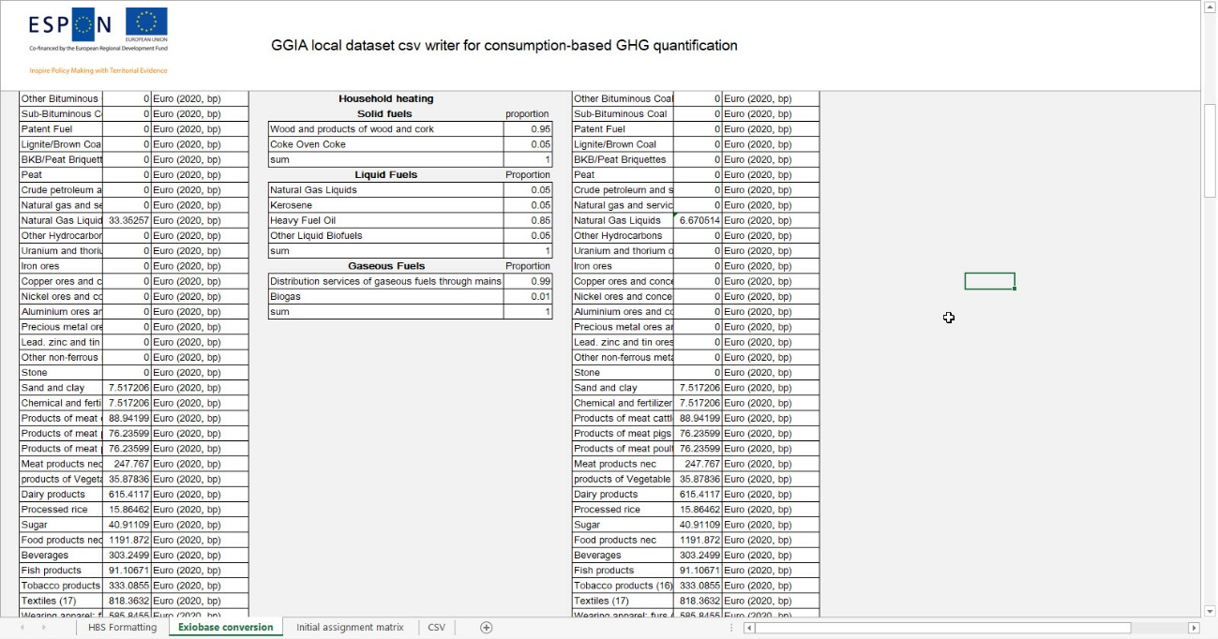

Figure 22). There are two options for solid fuels, four options for liquid fuels and two options for gaseous fuels. As ever, the proportions must sum to one for solid, liquid, and gaseous fuels, respectively. A source of this information could be the Eurostat database NRG_D_HHG, but other sources can also be used.



Figure 22. Creation of household heating data for local dataset.

**Saving the data**

Data representing the local area and suitable to be incorporated within the tool will be available in the middle column under the title “Modified Exiobase format” (column K). Once completed, the first and second column under the title “Modified Exiobase format” (J and K) should be copied and saved as a separate csv file. **Create local dataset** button will save the csv file in the right format in the same folder where the Excel file is saved on the local computer. The content of the CSV file can be viewed on the worksheet “CSV”, but it should not be edited here.

The worksheets “Initial assignment matrix” provides additional information and is not needed in the process of local dataset creation.

## Delivery of a new local dataset

There are two ways to have a new local dataset uploaded in the GGIA tool.

1. Expert User without developer skills:

Create a new local dataset as described above. Send the csv file to ESPON EGTC e-mail announced in the GGIA tool with a request to upload it in the tool.

1. Expert User with developer skills:

Sign-in to Github. Fork GGIA backend (and eventually clone and test together the GGIA frontend). Create (and test) the new local dataset on your local computer. Insert the new local dataset into your new GGIA backend (forked) version, save or upload it, and then submit a pull request in Github.

## Data validation

The tool owner may have an interest to control the quality of local datasets published in the tool. This is a task to be included in the future development work. A feasible data validation process could apply for example a registration system for expert users who would like to have their dataset shared in the browser-based tool. Alternatively, a background report with a standardized structure could be required.

Evaluation of the methodology and the reliability of each local data source may be an impossible task. However, it is good to remember that territories and cities are already publishing their studies based on this kind of local data sources, without external data validation, and are making important decisions on their climate action based on the results from these unharmonised GHG inventories.

The local dataset feature in the GGIA tool is an opportunity to start collecting territorial and municipal GHG quantification data that has not been collected in any European database so far. An increasing number of local datasets, together with proper tool maintenance and development, could make GGIA the leading tool for quantifying the GHG emissions in spatial planning and publishing this information for sharing of best practises.

### Validation principles for a local dataset serving territorial quantification

As argued in the final report of the QGasSP project, the data collection for territorial quantification is not harmonized. The case studies of the QGasSP project (Annex 4, Annex 5) show that local GHG inventories tend to apply a variety of data sources that are selected for their availability and applicability. Very few of these – if any – are European databases.

A data collection standard or guideline would be an important step towards better comparability, but it is not within reach in this project.

First steps towards more harmonized data collection could for example a systematic application of the CSC factors from national inventory reports on land-use change - or use of the COPERT tool data on transport. However, any territory or city that has already published a GHG inventory would probably like to use the existing baseline as it is - and not revise it unless a European standard or widely accepted guideline starts to harmonize the practice.

### Validation principles for a local dataset serving consumption-based quantification

As explained in the previous chapter, the local dataset for the consumption-based quantification should be composed from a local household budget survey (HBS) conducted for the local region. In total, there are 63 categories in the HBS used by the tool. The categories follow the Classification of Individual Consumption by purpose (COICOP), set out by the United Nations statistics division.

# Access to code – Developer User

To encourage the further development and application of the tool, the code is published open-source. It is available for a developer user who is interested in tailoring the tool properties, inserting new quantification modules in the territorial quantification or improving the functionality of the tool.

All the code of the QGasSP GGIA project is publicly available at <https://github.com/QGasSP> under an MIT license. Of main interest are here <https://github.com/QGasSP/ggia-backend> (including all the computational data for the project) and <https://github.com/QGasSP/ggia-frontend> (all the user interface code).

The backend uses Python, dataframe computations based on pandas (<https://pandas.pydata.org/>), and flask (<https://flask.palletsprojects.com/>) for the web request layer.

The frontend is implemented with Storybook (<https://storybook.js.org/>) and React (<https://reactjs.org/>).

The easiest way of running an instance of these locally is through the use of a docker environment and following the respective readmes on the top level pages of these repositories (so both frontend and backend have to be instanced, the frontend dockerfile-compose-dev.yml has to be adjusted to point to your local backend instance).

To extend this project with new features, the repositories can be forked and modified in a local environment.

# References

Capros et al (2016) EU Reference Scenario 2016. Energy, Transport and GHG emissions. Trends to 2050. European Commission. Directorate-General for Energy, Directorate-General for Climate Action and Directorate-General for Mobility and Transport.

Copernicus Land Monitoring Service (2018) Urban Atlas: Street Tree Layer (STL 2018).   
Available at: https://land.copernicus.eu/local/urban-atlas/street-tree-layer-stl-2018?msclkid=a885ee26be1211ecbdd810a395525cb5  
(Accessed 17 April 2022).

FAO (2014) World reference base for soil resources 2014. International soil classification system for naming soils and creating legends for soil maps. Update 2015. World soil resources reports 106, Rome.

FAO (2020) Global Forest Resources Assessment 2020. Main report. Food and Agriculture Organization of the United Nations. Rome. <https://doi.org/10.4060/ca9825en>

IPCC (2019) Refinement to the 2006 IPCC Guidelines for National Greenhouse Gas Inventories.

Kosztra et al (2017) Updated CLC illustrated nomenclature guidelines, Wien: European Topic Centre on Urban, land and soil systems ETC/ULS.

|  |  |
| --- | --- |
|  |  |
|  |  |
|  | ESPON 2020  ESPON EGTC  4 rue Erasme, L-1468 Luxembourg  Grand Duchy of Luxembourg  Phone: +352 20 600 280  Email: [info@espon.eu](mailto:info@espon.eu)  [www.espon.eu](http://www.espon.eu)  The ESPON EGTC is the Single Beneficiary of the ESPON 2020 Cooperation Programme. The Single Operation within the programme is implemented by the ESPON EGTC and co-financed by the European Regional Development Fund, the EU Member States, the United Kingdom and the Partner States, Iceland, Liechtenstein, Norway and Switzerland.  Disclaimer  This delivery does not necessarily reflect the opinion of the members of the ESPON 2020 Monitoring Committee. |
|  |  |

1. The impact of local GHG mitigation policies can be included in the baseline scenario through a local dataset, see chapter 1.5.
2. CORINE classes: artificial areas (112–142); agricultural areas (211–243); forest and semi-natural areas (311–324); wetlands (411–421); water bodies (511–523).
3. WRB soil classes: CM - Cambisol; HS - Histosol; LP - Leptosol; PZ - Podzol.